

**Web Application Pen-testing**

Year 2 (2025/26), Semester 3

**SCHOOL OF INFOCOMM TECHNOLOGY**

Diploma in Cybersecurity & Digital Forensics

**ASSIGNMENT**

|  |  |
| --- | --- |
| **Weightage:** | 40% of Module |
| **Individual/Team/Both:** | **Both** |
| **Format:** | Font Arial  Font Size 11, 1.5 spacing |
| **Deadline:** | **Assignment report:**  **10 August 2025 (week 16 Sunday), 2359hrs**  Softcopy via Brightspace Assessment  **Individual reflection:**  **10 August 2025 (week 16 Sunday), 2359hrs**  Softcopy via Brightspace Assessment  **Presentation:**  **To be arranged with tutor (on week 17)**  Presentation aids (if any) to be uploaded after presentation |

**Penalty for late submission**:

10 marks per day (including Weekends and public holiday).

No submissions will be accepted after **17 August 2025, 2359hrs**.

1. Executive Summary 1

2. Domains: www.kiwi.com & auth.skypicker.com 3

2.1 Reconnaissance 4

2.2 Automated Application Scans 5

2.3 Manual Application Testing 8

2.4 Potential Findings 12

2.4.1 Refresh Token Replay Vulnerability 12

2.4.2 Session Hijacking 14

2.4.3 Cross-Device Session Persistence Testing 18

3. Domain: tequilla.kiwi.com 20

3.1 Reconnaissance 20

3.2 Automated Applicaiton Scans 21

3.3 Manual Application testing 23

3.4 Potential Findings 27

3.4.1 Missing Content Security Policy (CSP) 27

3.4.2 Cross-Origin Resource Sharing (CORS) Misconfiguration 29

4. Domain: jobs.kiwi.com 30

4.1 Reconnaissance 31

4.2 Automated Application Scans 32

4.3 Manual Application Testing 34

5 Business Story: 36

5.1 Business Owner (Javen) 36

5.2 Chief Security Officer (Joel) 37

5.3 Chief Security Officer (Joel) 37

5.4 Engineering lead (Wei Hong) 38

5.5 Engineering lead (Darrius) 39

6. Conclusion 39

7. Appendix: 40

7.1 Figures for www.kiwi.com & auth.skypicker.com: 40

7.2 Figures for tequila.kiwi.com: 56

Reconnaissance: 56

Automated Scan: 59

Manual Application Testing: 60

Potential Findings 66

Missing Content Security Policy (CSP) 66

Cross-Origin Resource Sharing (CORS) Misconfiguration 68

7.3 Figures for jobs.kiwi.com 70

8. References 75

# 1. Executive Summary

Our group consisting of Joel, Javen, Darrius and Weihong, participated in Kiwi.com’s bug bounty program to conduct a web application penetration testing. Kiwi.com is a leading global travel tech company, relied upon many users for searching and booking of travel itineraries around the world. Due to the sensitive nature of the data handled – including personal information and payment details, ensuring the security of the web application is important. As such, the primary goal of this penetration testing was to identify any potential areas of concern associated with the application in its current state and to determine the extent to which the system may be breached by an attacker.

Our group conducted the penetration testing during the period of August 5 – 11, 2025. All testing activities were conducted using dedicated test accounts and credentials provided by Kiwi.com. This helps to ensure that the testing done is safe and isolated and will have no impact on live business operations. The test environment includes dummy booking flows and payment mechanisms as shown below.

Emails used for Test Accounts:

* [nevaj@wearehackerone.com](mailto:nevaj@wearehackerone.com)
* [joelllt@wearehackerone.com](mailto:joelllt@wearehackerone.com)

Booking Flow Configurations:

* Add “&sandbox=true” as a query param to the URL
* Creation of cookie: “sandbox_payment=true”
* Usage of test details which include
  + Name: TEST TEST
  + Card: 4111 1111 1111 1111, Exp: 12/42, CVV: 123, Name: TEST APPROVE

The scope of the assessment is included in the following table:

|  |  |  |
| --- | --- | --- |
| Domains | Pen-Tested By | Purpose |
| **www.kiwi.com** | Joel, Javen | Main Customer-Facing Website |
| **tequila.kiwi.com** | Darrius | Business-to-Business (B2B)  Platform |
| **jobs.kiwi.com** | Wei Hong | Recruitment Page |
| **auth.skypicker.com** | Javen | Authentication API (used by www.kiwi.com) |

**Notes:**

* All scans conducted were conducted at a maximum rate of 2 requests per second (500m Delay) to avoid triggering rate-limiting mechanisms or causing denial of services.
* Screenshots of findings deemed significant by our group will be placed in the report section, and all supporting screenshots will be referenced and placed in the appendix section.

During the course of the penetration testing, our team has identified one potential critical severity that could lead to a full compromise of a user account. Apart from this, we have also found 1 high severity and some medium severity issues. The graph below shows the summary of the issues found.

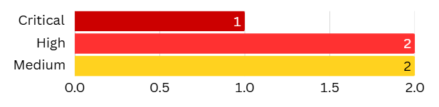

The table below also summarises the findings for OWASP Top 10 list for the web applications in the bug bounty. The OWASP Top 10 represents the list of the most critical web application security flaws.

|  |  |
| --- | --- |
| Category | Discovered |
| A1: Broken Access Control | Yes |
| A2: Cryptographic Failures | No |
| A3: Injection | No |
| A4: Insecure Design | No |
| A5: Security Misconfiguration | Yes |
| A6: Vulnerable and Outdated Components | No |
| A7: Identification and Authentication Failure | Yes |
| A8: Software and Data Integrity Failure | No |
| A9: Security Logging and Monitoring Failure | No |
| A10: Server Side Request Forgery (SSRF) | No |

Our group strongly recommends that all issues should be remediated as soon as possible, to prevent the compromise of sensitive information. These remediation strategies can be found together with the findings in each section. This includes section 2.4.1 - 2.4.3, as well as section 3.4.1 and 3.4.2.

In the report written below, it will summarise what our group has done to find these potential vulnerabilities, as well as the sstep-by-step approach we took to find them.

# 2. Domains: [www.kiwi.com](https://www.kiwi.com) & auth.skypicker.com

In this section, we will be conducting penetration testing on the main website, “www.kiwi.com”, as well as the authentication API page, “auth.skypicker.com” used by it. It will also include sub-sections such as the automated application scans used for reconnaissance, and the manual application testing based on parameters that could be vulnerable.

## 2.1 Reconnaissance

* Usage of Google Extension – Wappalyzer (Figure 2.1A)

With reference to Figure 2.1A, we identified that the site [www.kiwi.com](https://www.kiwi.com) uses technologies like Google Cloud, Cloudflare, Forter, PayPal, and Tailwind CSS. This tells us that the site has strong security and CDN protection, so scans should be cautious and tailored to avoid blocks.

* Web Application Firewall (WAF) Detection – Wafw00f

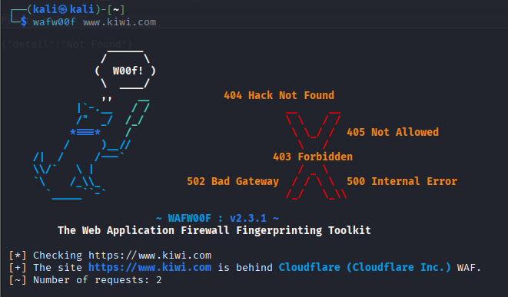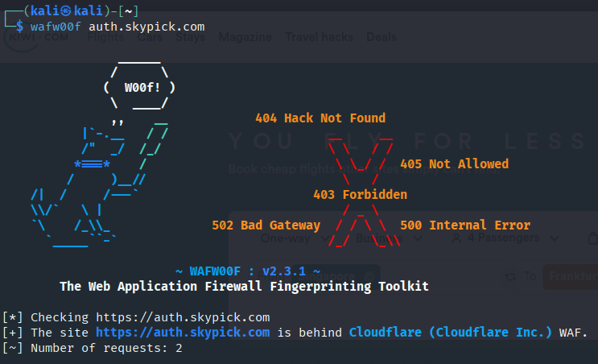

Using WafW00f, we found that both web applications are protected and sit behind Cloudflare WAF.

* Port and Service Scan – nmap

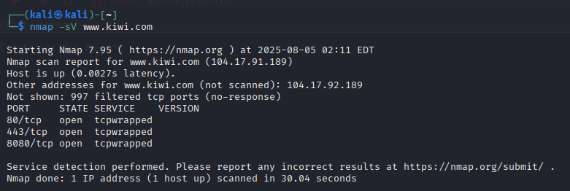

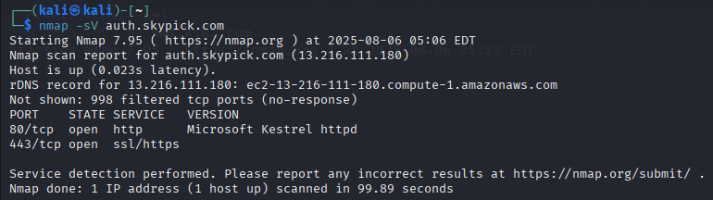

For Kiwi.com, ports 80, 443 and 8080 are open, but their services “tcpwrapped” likely because Cloudflare is preventing service identification. On the other hand, port 80 and 443 is open on auth.skypick.com, and uses Microsoft Kestrel, which is a cross-platform web server

* Domain Information Enumeration – whois (Figures 2.1B - 2.1C)

With reference to Figure 2.1B and 2.1C, the Kiwi.com domain is registered with MarkMonitor, and has been active since 1994, and will expire in 2034. Cloudflare name servers are used, and DNSSEC is not enabled. For auth.skypick.com, the domain is not registered to anyone.

* DNS Recon – nslookup (Figures 2.1D - 2.1E)

With reference to Figure 2.1D and 2.1E, Kiwi.com resolves to two IP addresses, 104.17.92.189 and 104.17.91.189, which are IP addresses part of Cloudflare’s network. Auth.skypick.com is resolved to 13.216.111.180

* Tech Stack Detection – whatweb (Figure 2.1F)

With reference to Figure 2.1F, the domain kiwi.com uses Shopify for its e-commerce infrastructure, and uses web technologies like HTML5 and JavaScript-based scripts. There are also security headers like “Strict-Transport-Security", “X-Content-Type-Options" and “Content-Security-Policy" for security. There are also cookies like “_cfuvid”. Performing whatweb on auth.skypick.com gives us information already found above.

## 2.2 Automated Application Scans

In this section, we used several commercial tools to survey our target applications and identify potential vulnerabilities such as parameters vulnerable to XSS or SQLI attacks.

* Fingerprinting - Securityheaders.com (Figures 2.2A - 2.1B)

We used curl to inspect the HTTP headers and response from kiwi.com, as shown in Figure 2.2A. We also used securityheader.com, to get more information as well, shown in Figure 2.2B. This revealed server info like Cloudflare, security headers like HSTS and CSP, cookies, technologies in use and external services.

* Automated Discovery of URL Parameters - paramspider

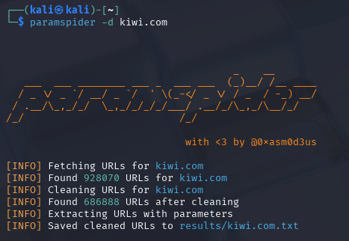

To discover hidden or potentially vulnerable URL parameters, we used the tool paramspider on kiwi.com. The scan identified over 920,000 URLs, and after cleaning, extracted 686,888 valid URLs. Many of which include parameters that can later be tested for issues like XSS, SQLi, or open redirects.

* Web Application Spidering - Zaproxy

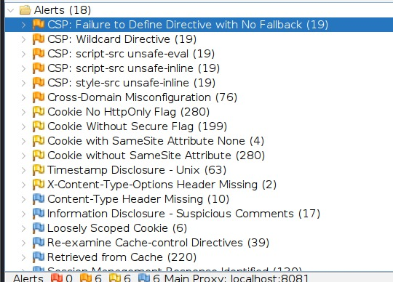

We decided to spider after paramspider to see some of the alerts as there were too many. The spidering on Zaproxy we found multiple CSP configuration weaknesses on Kiwi.com, as shown in the screenshot above such as missing fallbacks, wildcard sources, and permissive settings like the use of unsafe-inline and unsafe-eval in script-src and style-src. Such configurations can weaken the site’s protection against XSS and other code injection attacks if exploitable vulnerabilities are present elsewhere.

WhatWeb, Spidering and Fingerprinting confirm that CSP is present but not optimally configured.

* Vulnerable JS Library Scan - Retire.js (Figure 2.2C - 2.2D)

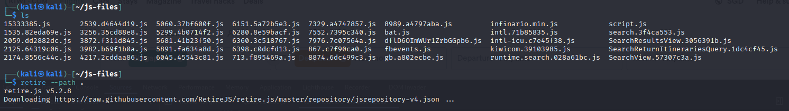While inspecting DevTools, under the sources tab, we noticed many JavaScript-based scripts being used. Hence, we tested for the use of vulnerable JS library versions that could be exploited using retire.js, which detects the version of JS libraries used, and flags if the version is vulnerable. With reference to figure 2.2C and 2.2D, we downloaded all JS files by using the console to dump all JS files used, then using ”wget” to download all files. From the screenshot above, we were unable to find any JS files using vulnerable versions.

* Directory and Endpoint Validation from robots.txt - FFuF, Wfuzz (figure 2.2E)

As seen in figure 2.2E, We used FFuF to check if any disallowed hidden or undocumented directories from robots.txt are accessible on <https://www.kiwi.com>. The kiwi_path.txt stores the information from entries found in the site’s robots.txt file. There were several endpoints, like “/user” which returned the status code 403, which confirms that they exist but are restricted.

Both the curl that pulled disallowed paths from robots.txt and the FFuF that tested the paths show both discovery and validation of sensitive endpoints.

* Subdomain & DNS Enumeration – DNSdumpster (Figure 2.2F)

[DNSdumpster](https://dnsdumpster.com) passively mapped kiwi.com and revealed a wide range of subdomains hosted primarily behind Cloudflare. It also identified TXT records, mail servers, and integration with third-party services like OpenAI, Atlassian, and Docusign. This is seen in Figure 2.2F.

* Passive Subdomain Enumeration – amass (Figure 2.2G)

Used Amass to passively discover DNS info for kiwi.com. We found nameservers, mail servers, and IPs tied to Cloudflare and Google. There were also no active subdomains discovered in this scan. This can be seen in Figure 2.2G.

* Parameter Fuzzing for Injection Points – wfuzz (Figure 2.2H)

As seen in Figure 2.1H, to test for parameter injection vulnerabilities, we used Wfuzz, a tool designed for fuzzing web applications by injecting payloads into parameters. This command attempts to inject different values into the id parameter of the URL, checking for anomalies or unexpected responses that might indicate a vulnerable input. It helps identify endpoints susceptible to manipulation, such as SQLi, LFI, or XSS.

* Automated Cross-Site Scripting (XSS) Testing - xsser (Figure 2.2I)

Using XXSer, we tested the parameter on <https://www.kiwi.com/search> with 1334 payload variations, including <script>alert(1)</script>, to detect any possible XSS vulnerabilities. However, there were no successful payload execution that was observed, suggesting that the parameter is not vulnerable based on the tested payload set. This can be seen in Figure 2.2I.

* SSL/TLS Strength testing (Figure 2.2J) - sslscan

Using sslscan, we found out that kiwi.com supports strong protocols like TLS 1.2 and 1.3, and secure ciphers with modern cryptography. Legacy protocols are disabled, and heartbleed is not exploitable. TLS Fallback SCSV is also supported. This can be seen in Figure 2.1J.

* Web server vulnerability assessment - nikto (Figure 2.2K)

Using Nikto, we found out that there were missing X-Frame-Options, this means that there are clickjacking risks, insecure cookies lacking “HttpOnly” or “Secure” flags, internal IPs disclosed, and an exposed endpoint at /api/report/. This can be seen in Figure 2.2K.

* Robots.txt Enumeration – curl command (Figure 2.2L - 2.2M)

Using curl, we extracted disallowed paths from robots.txt on kiwi.com. It revealed potentially sensitive endpoints like /api, /account, /manage, and query-based paths. This can be seen in Figures 2.2L and 2.2M.

## 2.3 Manual Application Testing

From the Automated Application Scans section, we were unable to find or obtain any useful results that could indicate a potentially exploitable vulnerability. Hence, in this section, our group will also be using manual testing techniques to identify and attempt to exploit additional vulnerabilities in the two domains.

**2.3.1 Authentication API (Figures 2.3A - 2.3D)**

By filtering the HTTP history in Burpsuite by “auth.skypicker.com”, we learnt that the authentication API is called for two uses. The following explanation and tests are with reference to figure 2.3A to 2.3D.

The first call is when a user logs into their account. The user receives a unique transaction ID in the when a POST request is sent to the endpoint /v2/user/otp/request, and this transaction ID is used together with a One Time Password (OTP) to authenticate the user in the POST request with the endpoint /v2/user/otp/login.

The second call is when a logged-in user reopens the browser or around every 50 minutes. When this happens, the user sends POST request with a refresh token to the endpoint /v2/token/refresh and receives an access token and another refresh token.

For the refresh token that a user receives from the server’s response, our team believes that there could be a possible vulnerability, so it will be elaborated in section 2.3.1 with the proof of concept.

**2.3.2 IDOR on Authentication (Figures 2.3E)**

When a user logs into their own account, a POST request with their email and brand is sent to the server, and the user receives a transaction ID. If IDOR is possible, then user A could alter this request to another user B’s email and obtain a valid transaction for user B, threatening confidentiality if the transaction ID could be used to authenticate user A into user B’s account. However, through testing, the web application does not allow this, and returns a 409-error message, stating that the requests conflicts with another request as seen in figure 2.3E.

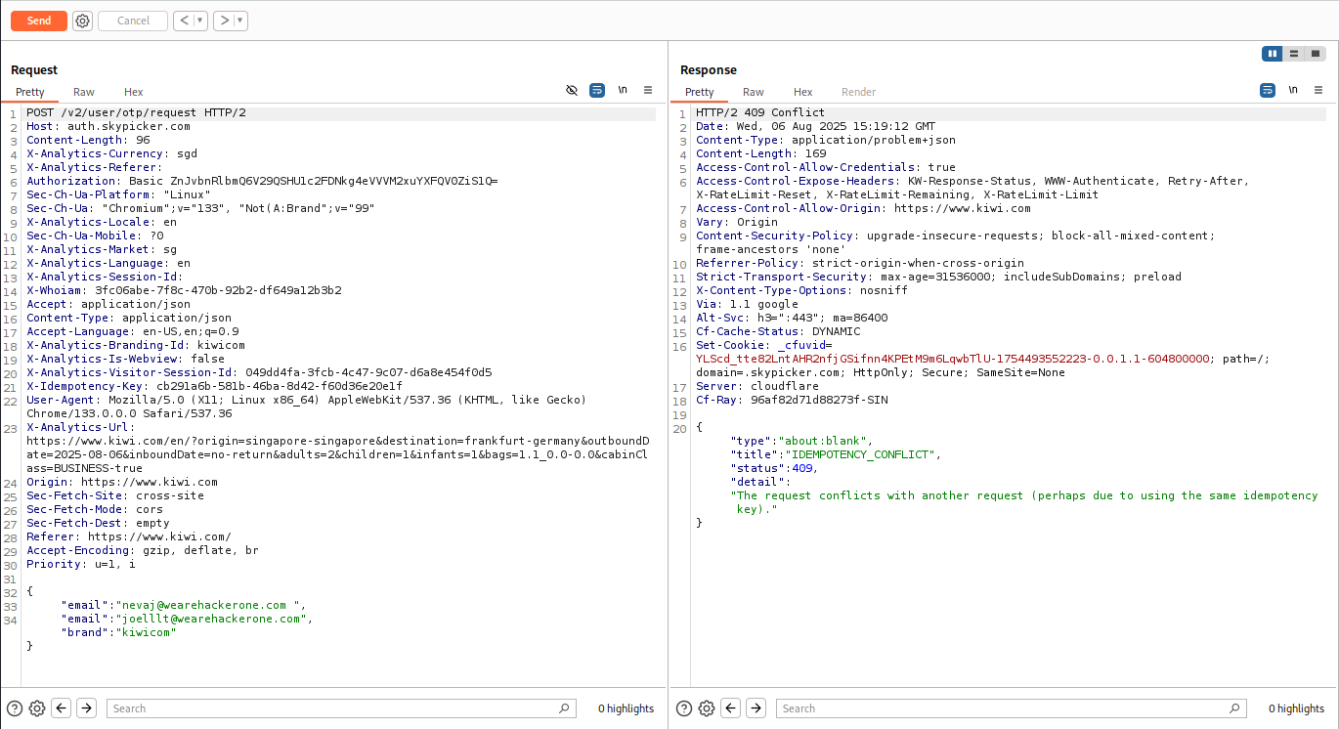

Next, we tried to add the email of the other user below the original email, but we receive the same error message. This shows that IDOR on authentication to obtain a transaction ID was not allowed on the web-application

**2.3.3 Testing GraphQL Server**

The web application uses GraphQL to retrieve information like recent searches or prices. GraphQL is a query language for APIs and enables clients to receive data from the server. It works in a way like SQL, such that there are schemas. Hence, we wanted to see if we could dump the schema used by the application, to obtain user information like their search history.

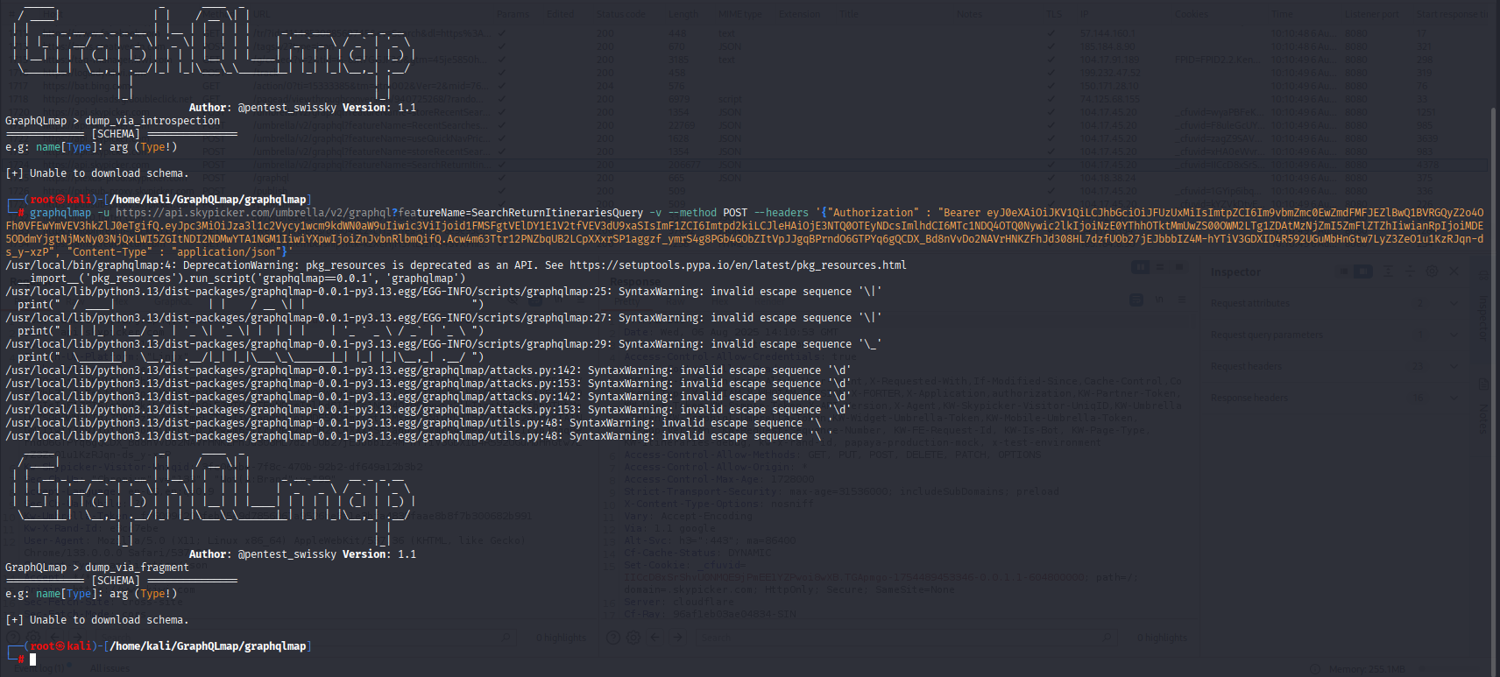

We used the tool GraphQLmap to test if we could dump the schema. To do so, we provided the URL, method, and headers like the JWT token and the content type of the request.

We were able connect to the GraphQL endpoint used by the domain, where we tried to dump the schemas using two methods, introspection and fragment. Introspection dumps the schema fully, while fragment dumps the schema in pieces. However, we were unable dump the schema. Hence, it shows that the web application has hardened the GraphQL server, preventing users from obtaining information stored in it.

**2.3.4 Application Authentication, Session Management, and Access Control**

**(Further details in 2.4 Potential Findings)**

To evaluate session management, the su_access_token authentication cookie was examined. In Browser A, the logged-in browser, the cookie value was copied from the application’s storage. In Browser B, the logged-out browser, the cookie did not exist, so it was manually created with the value taken from Browser A. Upon refreshing Browser B, the application granted full authenticated access without requiring a login. This demonstrates that the same su_access_token can be reused across different browsers or devices, and no additional verification is performed when a valid token is presented. More information is shown in the potential findings.

**2.3.5 Access Control Verification – Settings Page**

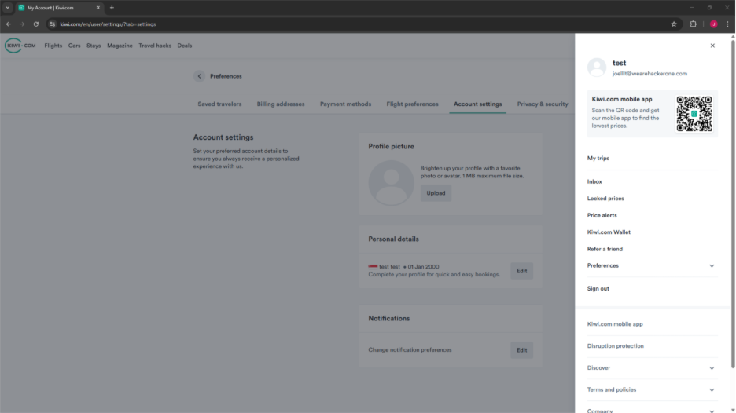  
Browser A, logged in as joelllt@wearehackerone.com

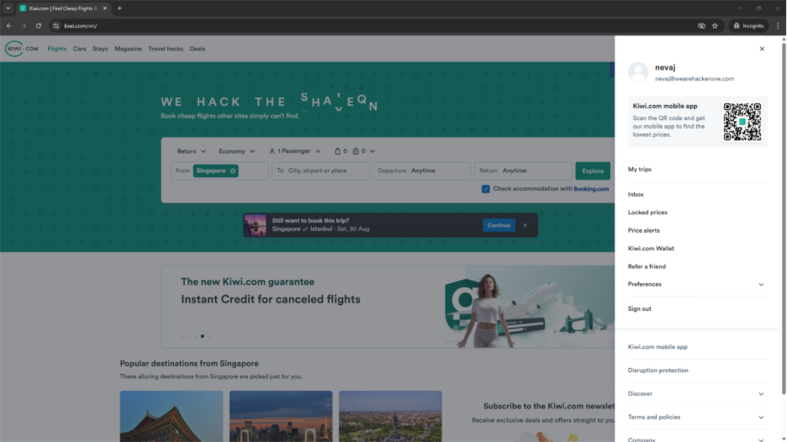  
Browser B, logged in as nevaj@wearehackerone.com

To verify the access controls, the direct URL to the settings page from one logged-in account, [joelllt@wearehackerone.com](mailto:joelllt@wearehackerone.com) was copied and accessed from a separate browser that is logged in to a different account [nevaj@wearehackerone.com](mailto:nevaj@wearehackerone.com). Browser 1 is logged in as joelllt@wearehackerone.com and is viewing its account settings page. Browser 2 logged in as nevaj@wearehackerone.com on the main page.

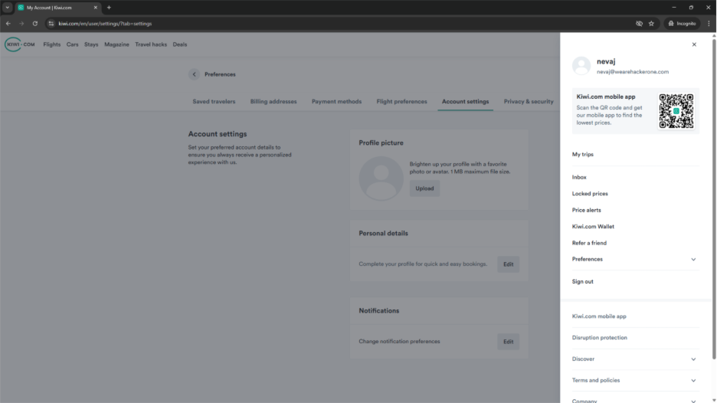  
Browser B, after pasting URL from Browser A

Upon pasting the link, the application redirected the second account to its own settings page instead of exposing the original account’s details.

This test confirms that Kiwi.com enforces proper session-based access control on the account settings page, preventing one authenticated user from directly accessing another user’s sensitive data via a shared link.

**2.3.7 Parameter Manipulation in Booking Flow (Figures 2.3F - 2.3M)**

**Test 1 – Currency Change**  
("currency": "EUR" → "currency": "USD")  
  
As shown in Figures 2.3F and 2.3G, the currency field in the JSON body was modified from "EUR" to "USD". The modified request resulted in a 500 Internal Server Error, which suggests that the backend did not handle the altered currency value well. This tells us that there is a stability issue, and it does not directly expose sensitive data or allow unauthorized actions.

**Test 2 – Passenger Category Change**  
("category": "adult" → "category": "child")  
  
Figures 2.3H and 2.3I show a modification of the passenger category field from "adult" to "child". The response returned a 400 Invalid passengers configuration error, telling us that the API validates the logical consistency of passenger details against booking parameters and rejects invalid configurations.

**Test 3 – Booking Phase Change**  
("booking_phase": "summary" → "booking_phase": "confirmation")  
  
In Figures 2.3J and 2.3K, the booking phase value was changed to attempt skipping ahead in the process. The API returned a 400 Bad Request with a message, which confirms that the attempts to skip ahead without completing the previous booking steps are blocked by the server-side validation.

**Test 4 – Account and Traveler ID Manipulation**  
(“account_id”: “g1zhMhI9apazbRbADnJSdA” → “account_id”: "invalid_id" + "traveler_id": "random")  
  
Figures 2.3L and 2.3M depict changing the "account_id" and "traveler_id" fields to invalid values such as "invalid_id" and "random". The request was rejected with a 400 Request body is not valid JSON error, showing that identifier integrity is enforced and any tampering results in an immediate rejection.

## 2.4 Potential Findings

In this section, we will be talking about the potential vulnerabilities that our group has found in the web application, [www.kiwi.com](https://www.kiwi.com). These vulnerabilities may cause the Confidentiality, Integrity or Authenticity of the web application to be compromised. However, these findings are based on proof of concepts and may not be legitimate vulnerabilities.

### 2.4.1 Refresh Token Replay Vulnerability

**Assessment of Impact:**

* CVSS Score: 6.3 (Calculation is in Figure 2.4A in Appendix)
* This vulnerability could allow users to repeatedly use a refresh token to generate a valid access token, which could lead to unauthorised access of user accounts. If exploited, it could result in user session hijacking.
* This would lead to the loss of customer trust and potential data breaches. If this happens, Kiwi.com could then lose its reputation and revenue. Hence, new systems could be implemented to minimise token lifespans or to ensure tokens can only be used once.
* This vulnerability may also violate industry standards from OWASP which includes:
  + A05:2021 – Security Misconfiguration, since the system allows refresh token to be reused, without invalidating it after use.

**Proof of Concept:**

The image below shows the server’s default response to the /v2/token/refresh POST request, where it generates an access token and refresh token.

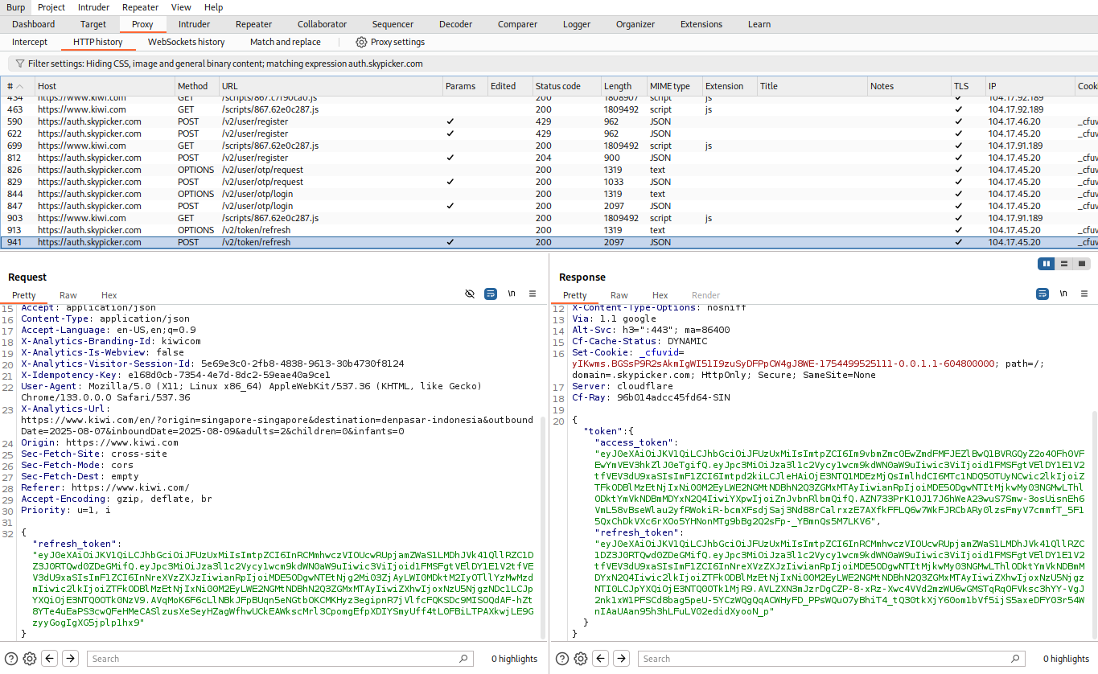

Next, we repeated the request 10 times using the intruder tool on Burp Suite, and for all 10 times, the same access token was received.

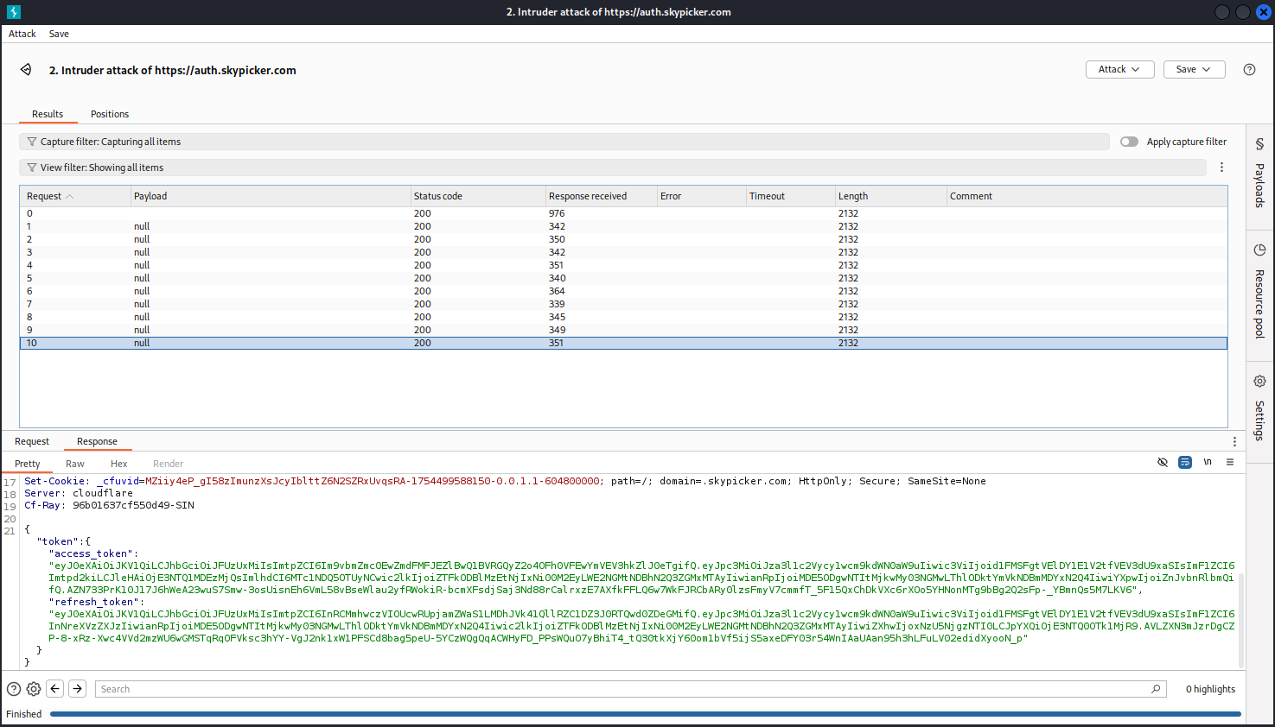

This means that the refresh token is not invalidated after use, and the access token is tied to the refresh token. If an attacker manages to obtain refresh token, he could use it to obtain a valid access token and potentially gain unauthorised access to the victim’s user account.

However, this is only a proof of concept, and we are unable to confirm if access to a refresh token would result in full session hijacking.

**Remediation Strategy:**

* Implement a refresh token rotation system, where after a successful generation of an access token with the refresh token, it will be revoked, and a new token will be used. This way, only the latest token is valid, and would prevent an attacker from repeatedly using a stolen token.
* Setting shorter expiry times on refresh tokens. Currently the refresh tokens change around every 50 minutes. By shortening the time that it takes to change the token, the window for exploitation is shorter, and could limit the impact in the case of a compromise.

### 2.4.2 Session Hijacking

**Assessment of Findings:**

* CVSS Score: 9.1 (Calculation is in figure 2.4B in appendix)
* The testing confirmed that there was a possible session hijacking vulnerability in Kiwi.com’s authentication mechanism. The su_access_token cookie is reusable across different browsers and devices without additional verification. By manually inserting a valid token from a logged-in session into another browser. Full authenticated access was obtained without any credentials or completing 2FA. This tells us that the sessions tokens are not bound to specific devices, IPs or session context. An attacker with access to a valid su_access_token could bypass all the login controls and directly take over the account.
* This vulnerability may also violate industry standards from OWASP which includes:
  + A07: Identification and Authentication failures -> the web application is unable to identify the correct user, and an attacker is able to authenticate himself as long as he has the su_access_token.
  + A:01: Broken Access Control -> An attacker may be able to obtain private information from the hijacked session

**Proof of Concept:**

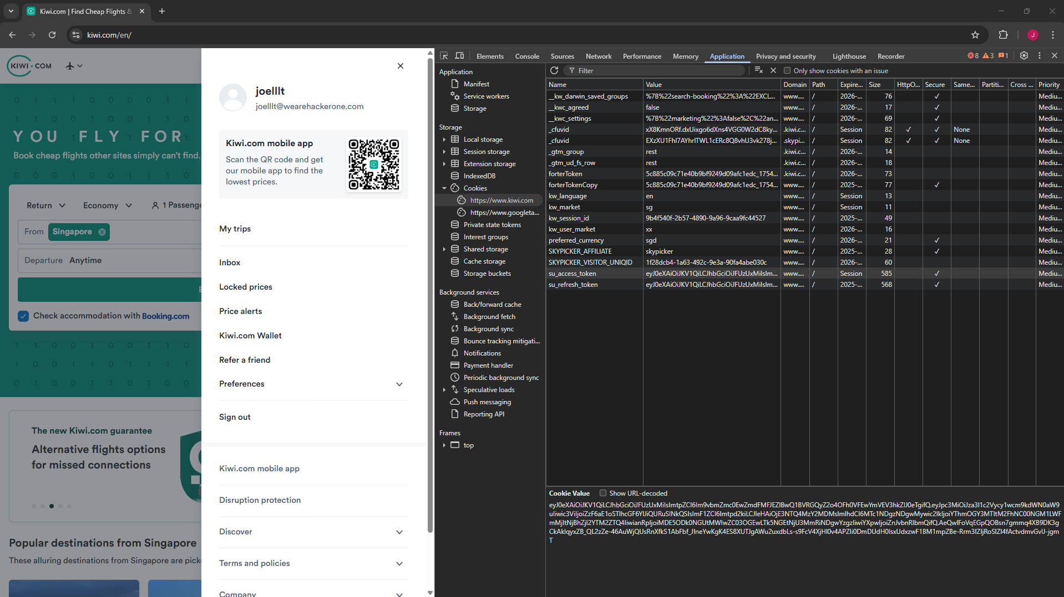

In browser A, I logged into my Kiwi.com test account, [joelllt@wearehackerone.com](mailto:joelllt@wearehackerone.com) and took the authentication cookie named su_access_token from the browser’s stored cookies.

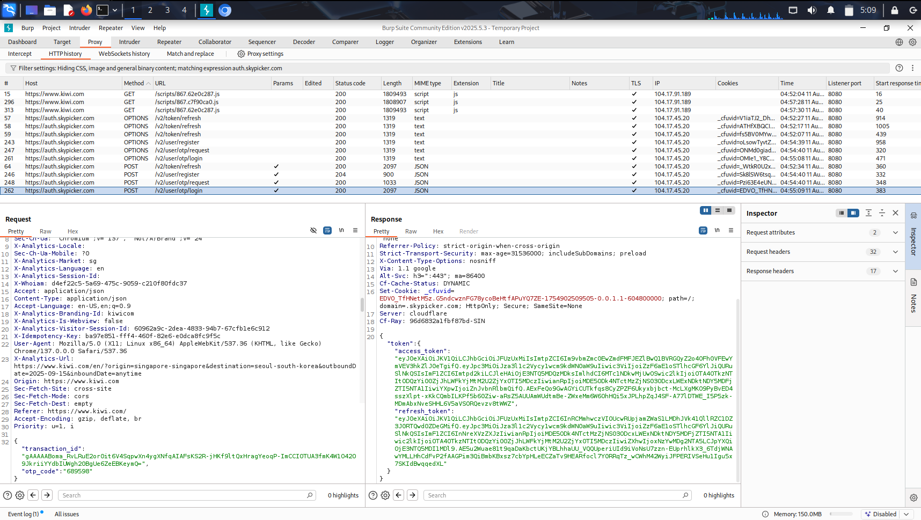

Burp Suite also managed to capture the request where there was the authentication cookie as well as seen in the Response section, under “access_token”.

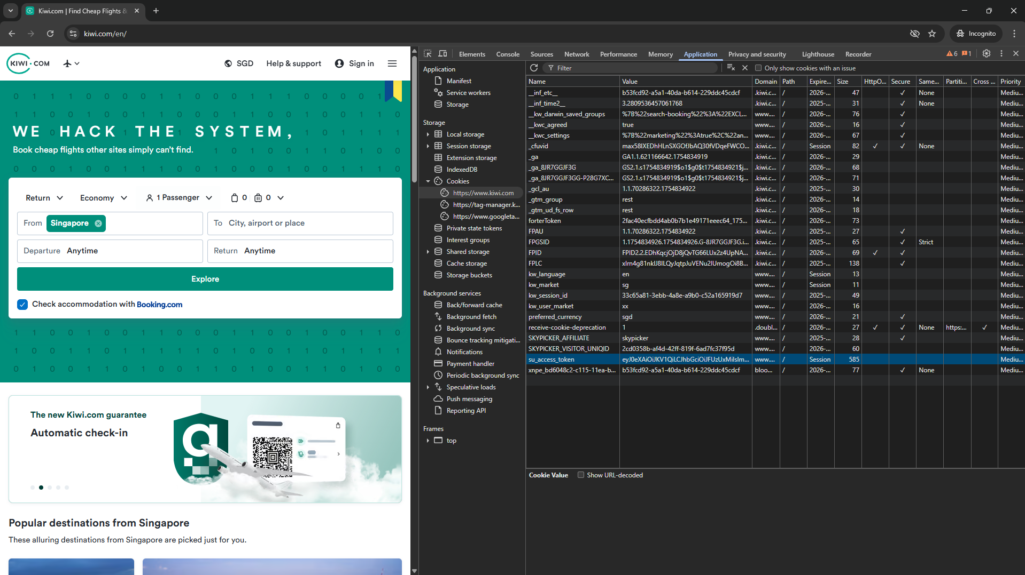

Then, in browser B, I logged out of the account and noticed that the authentication cookie, su_access_token did not exist in the logged-out browser, as it had no active session. So, I manually added it to test whether I could replace the cookie with the value from browser A to take the session from the logged-in browser. I had to specifically add the cookie named “su_access_token”, to be able to hijack the session using the cookie.

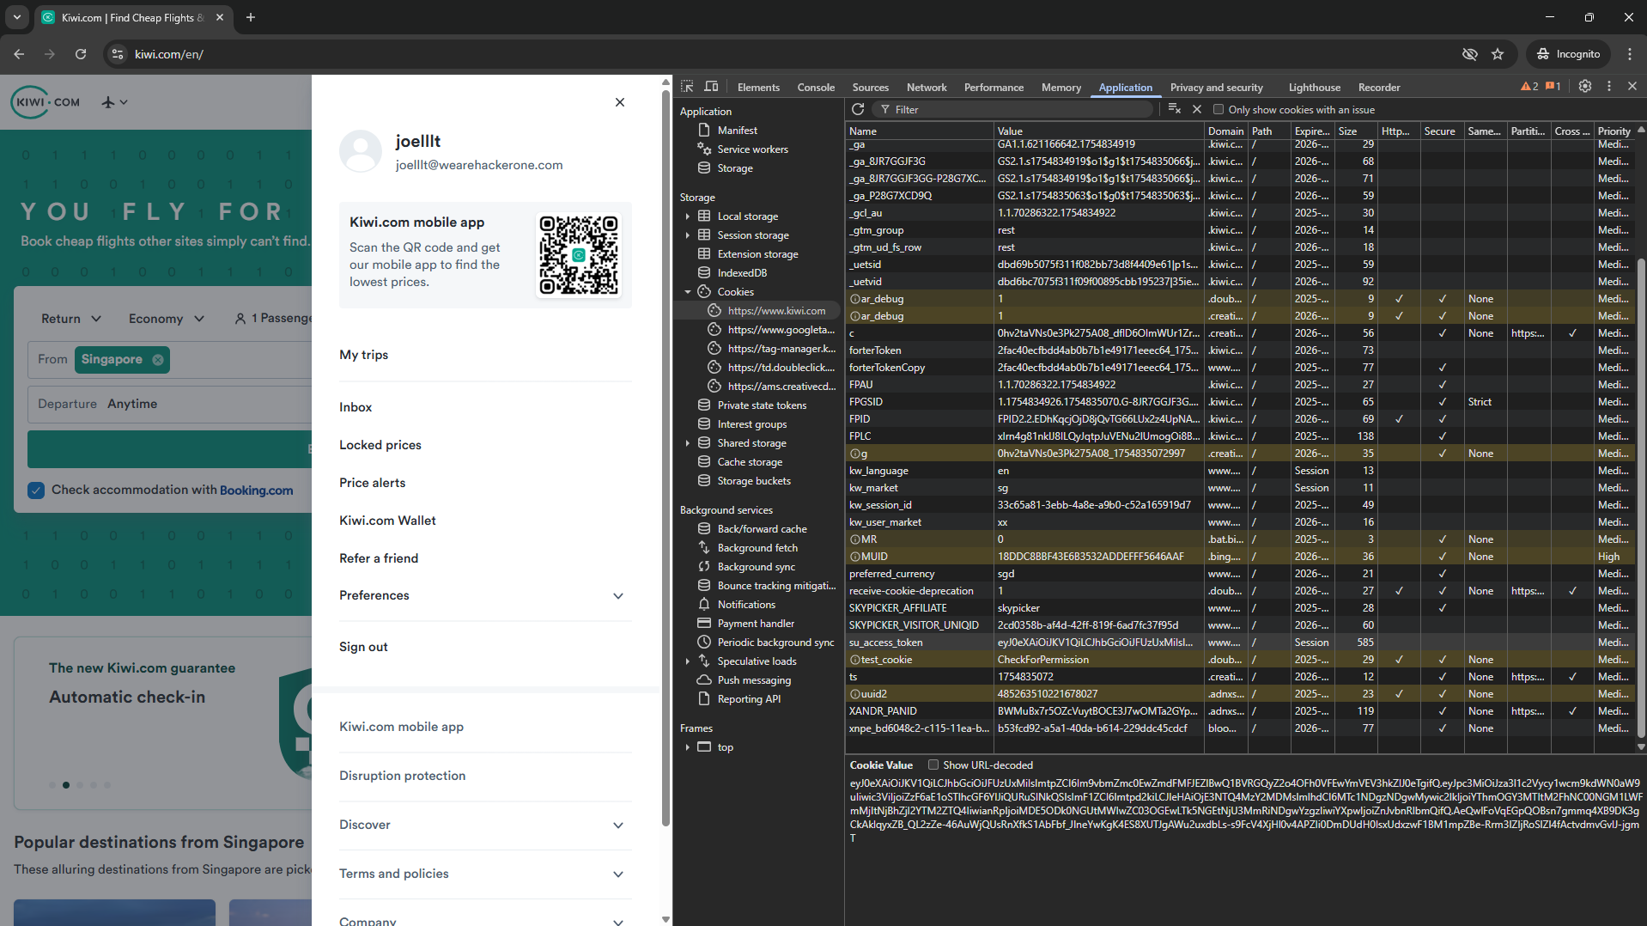

After refreshing Browser B, the session from Browser A was successfully loaded, granting full authenticated access without requiring any information like usernames, passwords or even two-factor authentication (2FA).

From the hijacked site, we were able to obtain some sensitive information about the user.

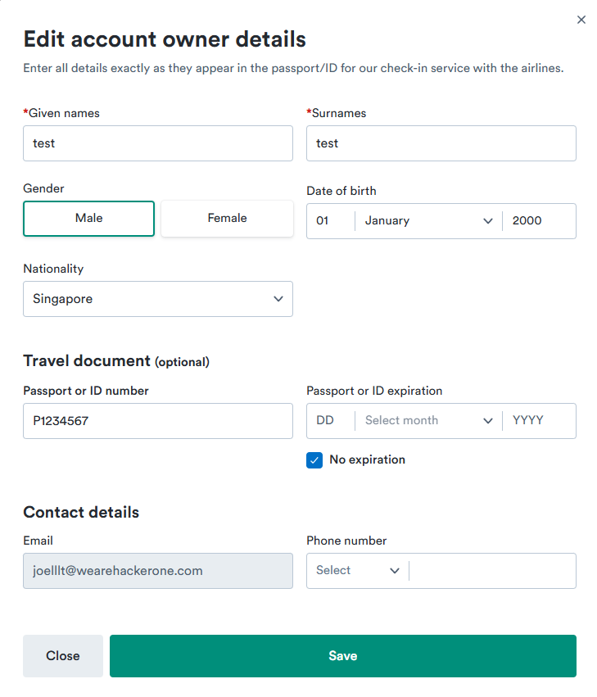

This image shows that the attacker can view the Passport or ID number. This exposes high value Personally Identifiable Information (PII) that can be used for identity theft, social engineering or even document forgery. The leakage of this official document numbers could have sever privacy and legal implications placed on the victim.

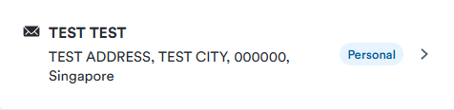

This image shows that the attacker can view the full name, street address, city, postal code, and country of the victim. This means that the attacker can commit targeted fraud, phishing, or other social engineering attacks when knowing all this information. The exposure of this would lead to danger and risks for the victim’s physical security and privacy.

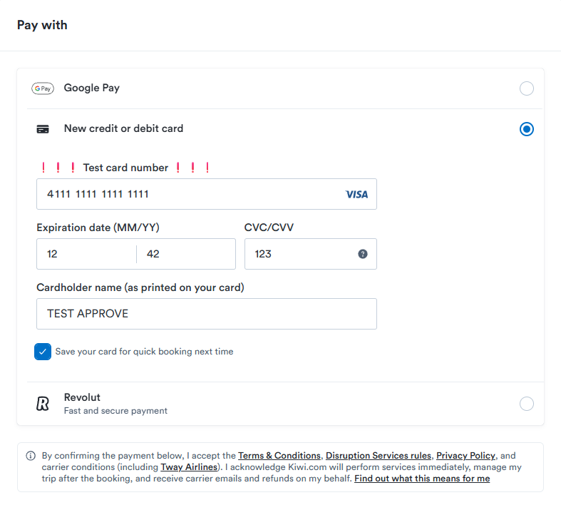

This image shows that the attacker can make use of the saved card details on the website if the original owner of the account had saved the card when booking their flights. This means that the attacker could attempt to abuse the stored payment details by having unauthorised financial transactions on the website, this however, is only possible if the CVC/CVV does not require to be re-entered. However, this could still lead to financial losses and possible liabilities for the victim.

This means that the authentication cookie is reusable across sessions and devices without additional verification, this allows an attacker with access to this token to take over an account without needing the password or two factor authentication (2FA). This behaviour enables session hijacking if an attacker can obtain a valid su_access_token, bypassing authentication entirely.

**Remediation Strategy:**

* Bind each given su_access_token to the browser or to the IP address of the user. By doing so, if an attacker can obtain a su_access_token of a user, they would not be able to authenticate themselves because the IP address of the attacker does not match that of the user, helping to prevent session hijacking.
* Implement device-based authentication. This means that if an attacker tries to use a stolen su_access_token to authenticate themselves using their own device, they will need to re-enter a password or complete a 2FA. This would prevent session hijacking and alert the victim that their account may be compromised.
* Implementing device-based session tokens. This means that only that device would be able to use those session tokens, anywhere else that attempts to use the cookies would not succeed.
* Enforcing complete logout across all sessions. This means that if the user logs out from one device or session, all other sessions and devices will be logged out as well, without having to manually log out of the accounts.

### 2.4.3 Cross-Device Session Persistence Testing

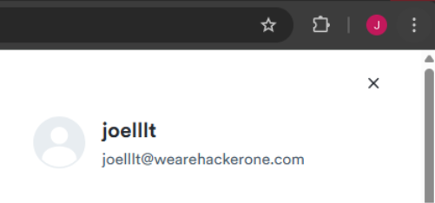

Browser A – Logged into joelllt@wearehackerone.com

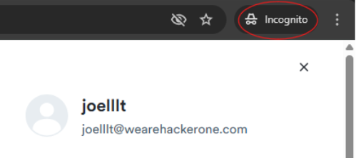

Browser B – Incognito, also logged into joelllt@wearehackerone.com

The same account was logged into simultaneously on Browser A and Browser B.

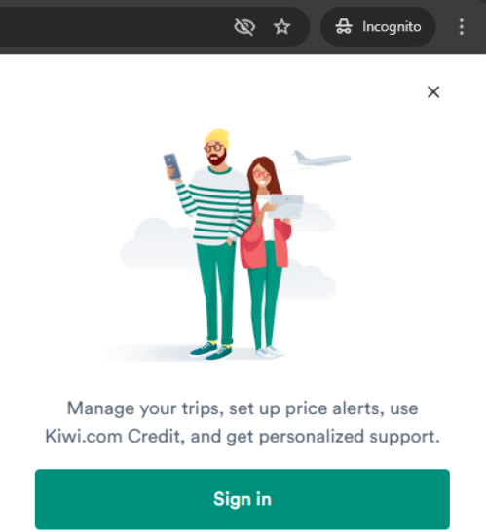

Browser B – Logged-out, incognito

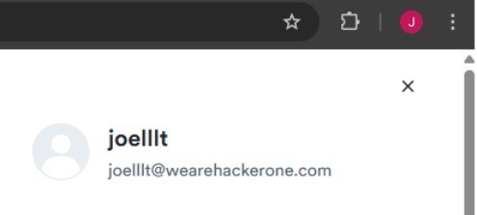

Browser A – Still logged in

I logged into the same account simultaneously on both Browser A and Browser B (incognito). Then, I proceeded to log out from Browser B. However, I noticed that Browser A remained logged in and retained full access to the account.

This behaviour indicates that the application does not revoke all active sessions when a user logs out from one device. If an attacker gains access to an active session. For example, through stolen cookies like tested above in session hijacking, or having compromised devices. Logging out elsewhere would not terminate their access, increasing the risk of unauthorised use until the session expires.

In conclusion, the lack of server-side session invalidation would mean that attackers would have hijacked a session can remain logged in even if the legitimate user logs out somewhere else. Furthermore, the stolen cookies would remain valid until they expire naturally.

I tested this theory with my teammate, Darrius, he used the cookie from my browser and managed to get into the account. Then, after I logged out, and logged back into the account, even though my cookie changed, and he was still on the old cookie, he was still able to access the account without problems. This would increase the risk of persistence on unauthorised access.

# 3. Domain: tequilla.kiwi.com

The following section showcases the penetration testing process on the domain tequilla.kiwi.com. The process of the penetration testing follows all scopes and program guidelines outlined by Kiwi.com bug bounty program. Testing methodologies such as automated scans, and manual application techniques will be applied to identify potential vulnerabilities in the domain.

tequilla.kiwi.com is a page that requires authentication through the login to access. To obtain the login credentials, we are required be an affiliate. Hence, we will only be testing portions of the page that is accessible to the public.

## 3.1 Reconnaissance

Identifying Technologies and Frameworks – WhatWeb (Figure 3.1A)

We were able to identify that the domain is being hosted behind Cloudflare. Security headers such as Strict-Transport-Security, X-Frame-Options [SAMEORIGIN] and X-XSS-Protection [i; mode=block] and the list of headers under UncommonHeader were implemented to ensure a strong security infrastructure. No misconfigurations or outdated frameworks were discovered. The implementation of Cloudflare acts as both a firewall and a reverse proxy that helps to block malicious activities and mask the server’s real IP. It makes it significantly harder to launch attacks on the actual infrastructure of tequila.kiwi.com.

Web Application Firewall (WAF) Detection – WafW00f (Figure 3.1B)

Through using WaW00f, we were able to confirm the firewall implemented. tequila.kiwi.com uses Cloudflare's Web Application Firewall (WAF). This is a strong firewall that blocks malicious payloads, XSS, SQL injection and other common exploitation attempts. Through the WAF implemented, it greatly reduces the effectiveness of direct attacks, requires more focus on application-layer testing to uncover vulnerabilities such as input validation flaws.

Directory Indexing Check – <https://tequila.kiwi.com/robots.txt> (Figure 3.1C)

Knowing that every site has robots.txt, we attempted to retrieve information from it to identify any disallowed directory paths that could disclose sensitive endpoints. However, the file returned a disallow: /. This suggests that the domain tequila.kiwi.com was intentionally configured to block indexing, which is likely done to prevent the leakage of sensitive information.

Directory discovery – FUFF (Figure 3.1D)

FuFF allows brute-forcing and the discovery of hidden directories on web servers. The command run aims to check if any endpoints from the wordlist, tequila_paths.txt, were accessible. Since robots.txt only contained a disallow: / , the wordlist defined did not contain any paths to test and FuFF was unable to discover any vulnerabilities or significant findings.

DNS Resolution – nslookup (Figures 3.1E - 3.1G)

Figure 3.1E shows DNS resolution through using nslookup. Tequila.kiwi.com was resolved to two IP addresses which are 104.18.33.68 and 172.64.154.188. These IP addresses are within Cloudflare as shown in Figure 3.1F and Figure 3.1G. It further highlights how the domain is being protected by Cloudflare’s content delivery network and web application firewalls.

## 3.2 Automated Applicaiton Scans

1. SSL/TLS Deployment – SSLScan (Figures 3.2A to 3.2C)

Based on Figure 3.2A to Figure 3.2C, it shows the SSL/TLS security configurations that are implemented for the domain. Figure 3.2A shows the use of modern and secure SSL/TLS protocols TLSv1.2 and TLSv1.3. It is important to know the SSL/TLS protocol versions being implemented as the older versions are known to be vulnerable since SSLScans confirms that the only modern SSL/TLS protocols are being implemented, there are no vulnerabilities detected here. From Figure 3.2B, it shows how the domain only makes use of strong and secure Cipher Suites to ensure secure communications. Figure 3.2C shows a highly secure and valid certificate. Through running SSLscan we can conclude that there are no exploitable weaknesses in the SSL/TLS deployment based on this scan.

* Detecting Vulnerable JS Libraries – Retire.js (Figure 3.2D)

Retire.js was used to scan for any outdated libraries that may contain vulnerabilities. Since there were no libraries found we can infer that all the JavaScript libraries are up to date. No vulnerabilities were detected.

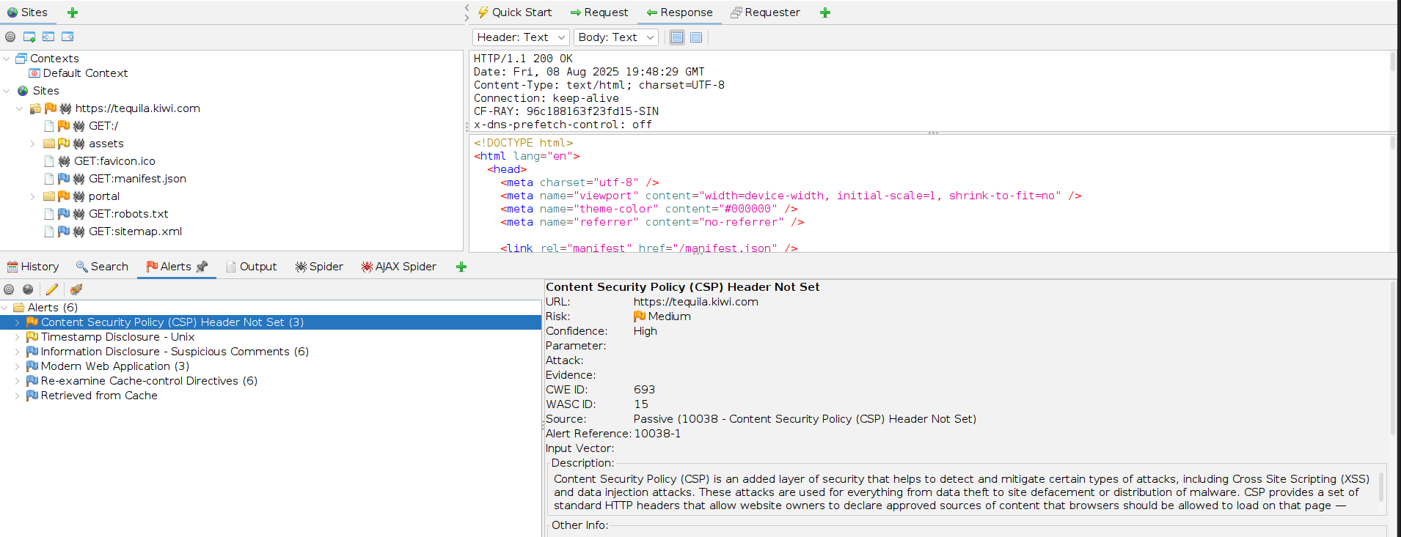Figure 3.2E - Spidering

1. Spidering the Site – Zaproxy (Figure 3.2E)

Using Zaproxy, scans that were limited to two requests per second were ran. It allowed us to crawl through the website to discover pages and directories that we were unable to reveal. It was also able to inspect the HTTP responses for misconfigurations and vulnerabilities. As shown in Figure 3.2E, after spidering, more pages were revealed alongside 5 alerts for vulnerabilities ranging from informational severity to medium severity. The most notable alert discovered was the missing CSP header. This supports what was mentioned earlier where the website fails to set up a CSP header successfully making it susceptible to XSS attacks.

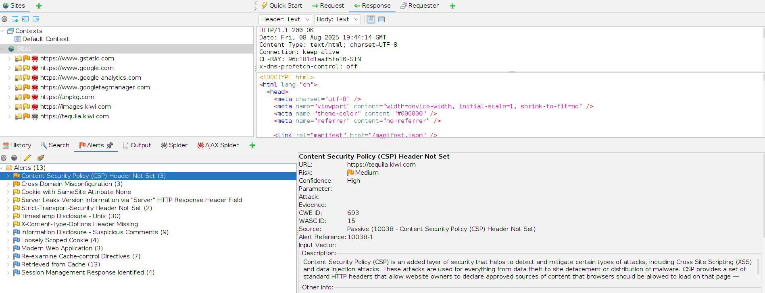Figure 3.2F - AJAX Spider

1. AJAX Spidering – Zaproxy (Figure 3.2F)

While crawling tequila.kiwi.com, Ajax Spider was able to pick up multiple alerts. Missing CSP headers were further alerted after discovering it though spider. However, another notable alert that surfaced during the Ajax Spider is the Cross-Domain Misconfiguration vulnerability. This is a vulnerability where a website’s CORS settings allow other domains to read data from its APIs. Misconfigurations of these settings allow attackers to access data from unauthenticated endpoints where data is weakly protected. An example of data being weakly protected is through relying on IP whitelisting where IPs are filtered based on who is able to access the data.

## 3.3 Manual Application testing

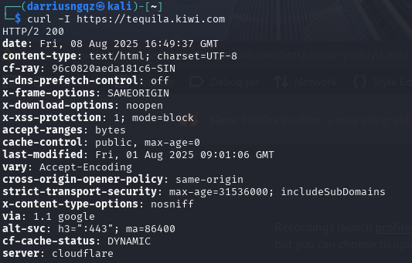

Figure 3.3A - Security Headers

Security Headers Deployment – curl

Figure 3.3A displays all the security headers that are present. Based on all the headers already implemented, it demonstrates a strong security infrastructure. However, CSP is notably missing from this list which could open the attack vector for XSS attacks. Though there is the header for X-XSS protection, this header is outdated and limited. It does not block XSS attacks completely and can be bypassed through payload encoding, breaking of script tags, DOM-based XSS and Stored XSS. To ensure that the web application is more secure, CSP headers can be implemented alongside the headers already present to ensure an additional layer of defence against client-side attacks.

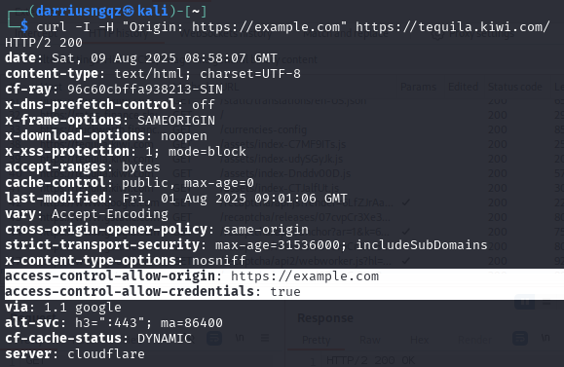

Figure 3.3B - CORS Misconfiguration

CORS Misconfiguration Secuity Headers - Curl

The command ran aims to show if tequila.kiwi.com allows for cross-origin requests from a random domain. Command sends a HEAD request to <https://tequila.kiwi.com> with a random origin header <https://example.com> to simulate a request coming from a third-party site. The purpose of this is to show CORS behaviour. The results tell us that the random domain was allowed to access credentials on cross-origin requests. It suggests that the CORS configurations are set to be too permissive as it trusts any websites that appears in the origin header. The browser sends back authentication information within the reply. Attackers can use this vulnerability to create a malicious website and trick a logged-in user into visiting it. The attacker can make requests top tequila.kiwi.com from the victim’s browser and read the responses containing the victim’s sensitive information. It allows the attacker to use the victim’s browser to exfiltrate data.

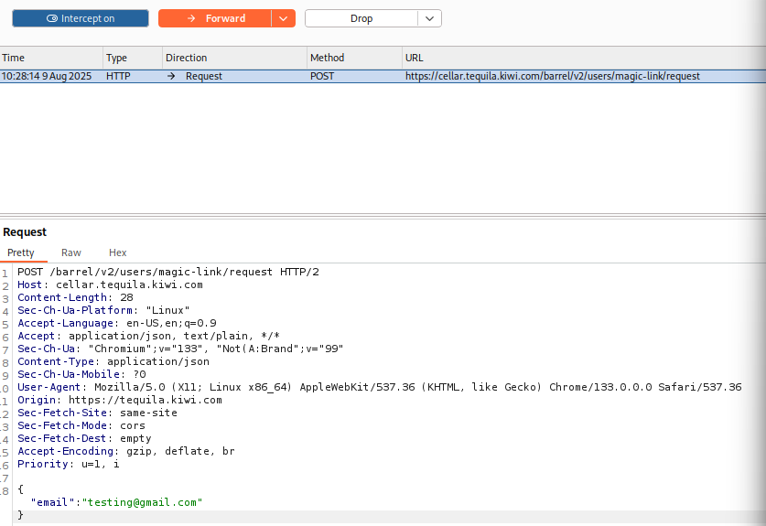

Figure 3.3C - Using Burp Suite Intercept

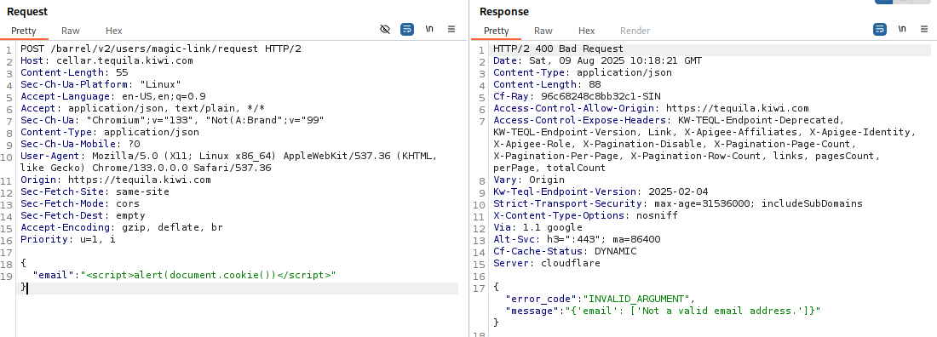

Figure 3.3G - Testing Email Input Fields for XSS

**Email Input Testing – Burp Suite (Figures 3.3C - 3.3J)**

Using Burp Suite Intercept, we are able to capture the exact HTTP request sent by the browser to the server when attempting to log into the web application. Figure 3.3C shows how the user request was intercepted and sent to the burp suite proxy under intercept allowing for more analysis and modification of the request parameters to test for vulnerabilities.

Figure 3.3C to Figures 3.3J shows testing of the input fields using XSS, HTML injection, SQL injection and unusual valid email formats. All the requests were done through burp Suite repeater and replied with 400 Bad Request or a 401 Unauthorised request. This implies that strong input validation and sanitisation was implemented to ensure that XSS and the injection of payloads are prohibited. No vulnerabilities were discovered through this testing.

Through the request sent, we can observe that proper CORS configuration was implemented on the subdomain cellar.tequila.kiwi.com. This contrasts with the main domain tequila.kiwi.com where CORS is misconfigured to accept any origin and credentials. This is a potential vulnerability that could increasing the attack surface.

**Password-based Login Page – Burp Suite (Figures 3.3K - 3.3M)**

An alternative login method was through being able to login using email and password. The same methods used during the testing of email input fields were used to test the password-based login page. The server constantly returned with a 401 unauthorised error which suggests that input sanitisation and validation was implemented. There were no indications of potential SQL or XSS vulnerabilities.

The request is sent to cellar.tequila.kiwi.com but the response headers shows that it is being processed by oldtequila.kiwi.com. Testing using curl allowed us to observe that oldtequila.kiwi.com reflects random origins and allows credentials which suggests CORS misconfiguration. Despite strong sanitisation being in place, it shows how the login endpoint can still be vulnerable to cross-origin attacks.

**Identifying Cookies – Developer Tools (Figure 3.3N)**

Through inspecting the web application using developer tools, we were able to identify that _inf_etc_ and _cfuvid had SameSite=None and _inf_etc did not have the HttpOnly. Since we were unable to login to the page, we are unable to check if these were vulnerabilities. However, to reduce the risk of CSRF and JS attacks, strict cookie policy enforcements are encouraged.

Based on the security headers implemented, it showed that there was an absence of CSP. This means that there is no policy which is enforced to control scripts running in the browser which could open a XSS vulnerability. Missing CSP and HttpOnly attributes can greatly increase the attack surface allowing for session hijacking or CSRF attacks. We are unable to verify this due to the inability to log into the domain, however, missing CSP and unstrict cookie configurations can introduce vulnerabilities and weaken the webpage’s security.

**Method Tampering – cURL and Burp Suite (Figures 3.3O - 3.3R)**

Figure 3.3O to 3.3R shows how we were able to test for whether unsupported HTTP methods could be used to access unauthorised resources. Method tampering tests were conducted through burpsuite and cURL by manually sending HTTP requests to <https://tequila.kiwi.com> using unsupported HTTP methods such as GET, PUT and DELETE. The server responded with 404 Not Found error as well as 401 unauthorised status which indicates that the server did not allow the methods for the tested endpoints. The requests were unable to be executed, and no vulnerabilities were detected on that end.

During this test we observe that the error page returned shows strict security headers implemented. On Figure 3.2O, we see that content-security-policy: default-src ‘none’ header is implemented which helps to restrict all resources and scripts from executing. However, as seen in the earlier scans, it is only implemented on the error page and not the main domain, tequila.kiwi.com. The absence of CSP headers on tequila.kiwi.com makes it vulnerable to XSS attacks and payload injection. The inconsistency in CSP headers being implemented shows misconfigurations in the web application and can lead to greater attack surface.

## 3.4 Potential Findings

### 3.4.1 Missing Content Security Policy (CSP)

CSP is a security standard that helps to prevent cross-site scripting (XSS), clickjacking and other code injection attacks. It places restrictions such that only the browser will be able to load resources such as JavaScript.

**Assessment of Impact:**

* Classified under OWASP A05:2021 – Security Misconfiguration
* CVSS Score: 0 None (Calculation in Figure 3.4.1.1 in Appendix)
  + Since no XSS vulnerabilities or injection vulnerabilities were discovered, there were no direct impacts discovered to the confidentiality, integrity and availability. The missing CSP headers shows a defence-in-depth weakness.
* Manual testing revealed that the domain and its endpoints lack CSP headers however, other security headers were in place. This shows a small lack in the defence-in-depth strategy. While it is not exploitable, it increases the impacts of any injection-related vulnerabilities and attacks.
* Without CSP in place, any discovered XSS vulnerability discovered would have a significantly higher severity score as any code injection will be executed allowing attackers to gain full control over the victim’s browser session. Attackers will be able to conduct attacks such as session hijacking, web page redirection, and load malicious scripts.
  + CVSS Score: 8.5 High (Calculations in Figure 3.4.1.2 in Appendix)
  + This increases the impacts of missing CSP header significantly.
* Based on the automated scans, we were able to detect that the target domain tequila.kiwi.com does not implement Content-Security-Policy (CSP) headers on any of its tested endpoints
* This increases the risk of XSS attacks, and code injection attacks which could lead to cookie theft, data theft, execution of malicious scripts and possible redirection to other malicious domains
* The impact of this from a business perspective
  + Data breach risk would lead to a non-compliance in the General Data Protection Regulation (GDPR)
  + Loss of customer trust
  + Financial losses through incident response, recovery costs and business downtime

**Proof of Concept:**

The absence of CSP headers were verified on all endpoints of the domain tequila.kiwi.com. Figure 3.4.1.2 to Figure 3.4.1.4 shows how no security headers were discovered during the manual testing to verify the automated scan results.

.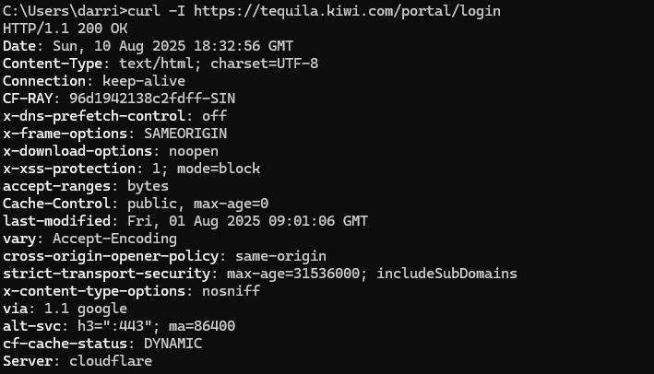Figure 3.4.1.3 - Main Login Page No CSP Headers

Based on Figures 3.4.1.3 to Figure 3.4.1.5, it shows how manual tests were conducted to obtain the security headers to check for any CSP headers being implemented but none were observed. Through viewing the HTTP headers that were set in Burp Suite and cURL outputs, we were able to conclude that there is a missing CSP headers vulnerability.

**Remediation Strategies:**

* To mitigate the risk of XSS, CSP headers should be added to all server responses. This tells the browser which sources are trusted and allowed for loading scripts, images and styles.

It can be implemented through:

Content-Security-Policy: default-src ‘self’; script-src ‘self’; object-src 'none’; frame-ancestors ‘none’; base-uri ‘self’

This CSP header is set to only load content and scripts that come from the same domain. It blocks all <object>, <embed> and <applet> tags to prevent any plug-in based attacks. Through disabling frame ancestors, it prevents the site from being embedded within frames or iframes which prevents clickjacking attacks. Base-uri ‘self’ helps to ensure taht all URLs lead to the same domain and prevents attackers from altering the <base> tag to load malicious content. With this CSP header in place, it prevents the loading of malicious responses and prevents the execution of unauthorised scripts. This significantly reduces the risk of data theft and session hijacking.

* To allow this recommendation to take place, the web administrators can safely deploy this without disrupting the site’s functionality and business continuity through the following procedures. Policy should be applied in Report-Only mode first. This mode helps to check for the policy being implemented. It does not block anything that violates it but logs the violation allowing web administrators to identify the scripts, images and other resources loaded by the domain that will be affected if the policy is implemented. Through this process, the web administrators are able to refine the policy through whitelisting the allowed domains which helps keep the policy as restrictive as possible. Only once the policy is verified to work without affecting all other legitimate resources it depends on, then the policy should be implemented.

### 3.4.2 Cross-Origin Resource Sharing (CORS) Misconfiguration

Cross-Origin Resource Sharing (CORS) is a browser mechanism that controls how web applications can request resources from different domains. CORS misconfiguration allows an attacker to use an attacker-controlled domain to bypass the same-origin policy and send authenticated requests to receive sensitive data from the target domain.

**Assessment of Impact:**

* Classified under: CWE-942: Permissive Cross-domain Policy with Untrusted Domains
* CVSS Score: 5.3 medium (Calculation in Figure 3.4.2.1 in Appendix)
* Manual testing was able to reveal that the CORS was configured to allow requests from any origins. Origins were able to send authenticated cross-origin requests to the target domain. The misconfiguration was present on all endpoints of the domain tequila.kiwi.com.
* While this vulnerability does not allow access to all sensitive data on the web application, it allows the bypassing of the browser’s same-origin policy which could allow attackers to obtain session information, sensitive user information.
* CORS misconfiguration allows an attacker to host malicious domains which are able to silently make requests using the victim’s active session to retrieve information and perform unauthorised activity.
* Based on the automated scans conducted, we were alerted of the CORS misconfigurations and further manual testing using curl allowed us to confirm the alerts.
* Impacts of this from a business perspective
  + Data breach risk would lead to a non-compliance in the General Data Protection Regulation (GDPR)
  + Loss of reputation and customer trust
  + Financial losses through incident response, recovery cost, legal action and business downtime

**Proof of Concept:**

We were able to prove for CORS misconfiguration through cURL to send requests using an unauthorised domain.  
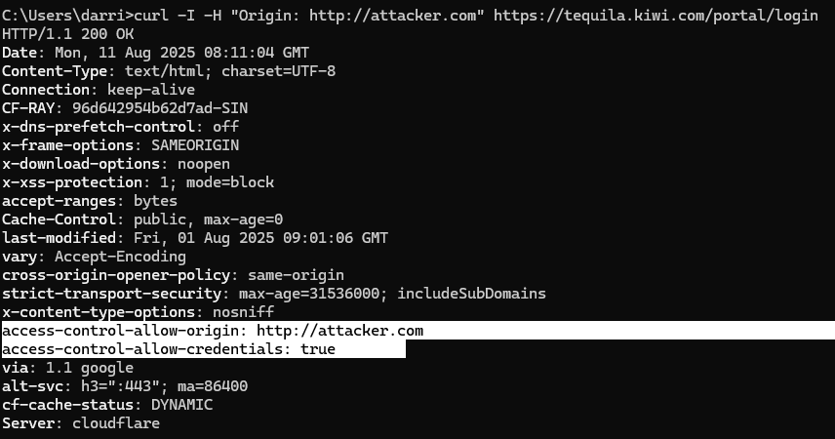Figure 3.4.2.2 - CORS Misconfiguration on Login Page

Based on Figure 3.4.2.2, it shows how the server allowed access from the requesting domain, http://attacker.com, which simulates an attacker domain. The response from the server showed access-control-allow-origin: http://attacker.com which shows how any domain can make authenticated cross-origin requests. Since access-control-allow-credentials: true is set, the browser will include the victim’s session cookies and authentication tokens in the cross-origin request. The misconfigured CORS policy allows JavaScript hosted on the attacker’s site to send an authenticated request to the target domain, tequila.kiwi.com, when visited by the victim. Attacker can then read the target server’s response and obtain the victim’s sensitive account data. Using the stolen data stolen obtained, the attacker can use authentication tokens and cookies to impersonate the victim and perform malicious activities.

**Remediation Strategies:**

* Restrict Access-Control-Allow-Origins to only allow trusted domains. This can be done through whitelisting domains that are allowed.
* Remove Access-Control-Allow-Credentials completely or only allow trusted domains through whitelisting.
* Ensure that strict validation is implemented on both the client and server side to verify that the requests are being made from approved domains.
* All endpoints that allow CORS must be reviewed to ensure that they do not allow the access to resources to unauthorised domains.
* To implement these features, it should be done in report-only mode to ensure that the implementations do not affect other legitimate and authorised domains.

# 4. Domain: jobs.kiwi.com

In this section, penetration testing will be conducted on the recruitment subdomain, jobs.kiwi.com, which serves as the careers page for Kiwi.com. The scope of testing includes passive reconnaissance and safe manual testing on all publicly accessible areas of the site. Although the site does not feature login functionality or sensitive transactional workflows, it contains interactive components such as a job search bar, which may be susceptible to client-side or input-based vulnerabilities if not properly secured.

Testing was conducted in accordance with Kiwi.com's public bug bounty program rules of engagement. Only non-destructive tools and techniques were used, and the request rate was limited to avoid any disruption to production services.

## 4.1 Reconnaissance

* Web Application Firewall Detection – Wafw00f (Figure 4.1A)

Once again, we used wafw00f to detect WAF on the domain. Like all other WAFs used by kiwi.com, the domain jobs.kiwi.com, is also protected by the CloudFlare WAF.

* Port and Service Scan – nmap

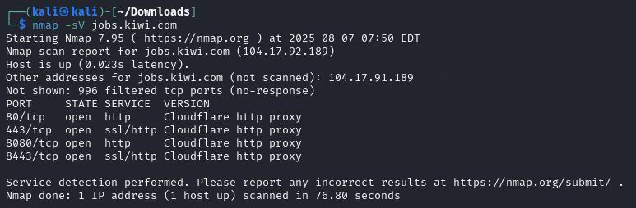

For this domain, ports 80, 443, 8080 and 8443 are open and all use cloudflare http proxy

Jobs.kiwi.com resolves to two IP addresses, 104.17.92.189 and 104.17.91.189, which are ip addresses part of Cloudflare's network.

* DNS Reconnaissance – nslookup (Figure 4.1B)

Based on the nslookup of the domain, jobs.kiwi.com, there are also 2 IP addresses, 104.17.92.189 and 104.17.91.189

* Tech Stack Detection – whatweb (Figure 4.1C)

The domain jobs.kiwi.com uses Cloudflare as its HTTP server, and implements web technologies such as HTML5 and JavaScript-based libraries like jQuery 3.7.1 and Modernizr. It is also hosted on WordPress. Security headers such as “Strict-Transport-Security” and “X-Content-Type-Options” are present, alongside cookies like “PHPSESSID” and “_cfuvid”, which suggest user session tracking and basic security hardening.

## 4.2 Automated Application Scans

* Web Server Vulnerability Assessment – nikto (Figure 4.2A)

Based on the output, the server used by jobs.kiwi.com operates on port 443 with TLS encryption. An internal IP address (0.0.1.1) was found in the set-cookie and _cfuvid cookie headers, which could disclose internal network information. There is an alt-svc header which indicates support for HTTP/3, but Nikto cannot test for vulnerabilities over this port. Lastly, uncommon headers such as host-header and x-proxy-cache-info were found, which could indicate that there is custom proxying or caching setups

* Robots.txt Enumeration – curl command (Figure 4.2B - 4.1C)

We retrieved the robots.txt file from jobs.kiwi.com to identify directories and endpoints that the website owner has explicitly disallowed search engines from indexing. While these disallowed paths are not always sensitive, they can sometimes reveal hidden or less-accessible functionality that may be of interest for security testing.

Next, using curl, the contents of the robots.txt file were retrieved from jobs.kiwi.com and filtered for disallowed paths. According to the screenshot above, the file revealed restricted endpoints such as /api, /job-alert/, /comments/, and wildcard-based patterns like /*?post_type=* and /*is_ajax*. This can be seen in Figure 4.1F

* Directory and Endpoint Validation from robots.txt - FFuF

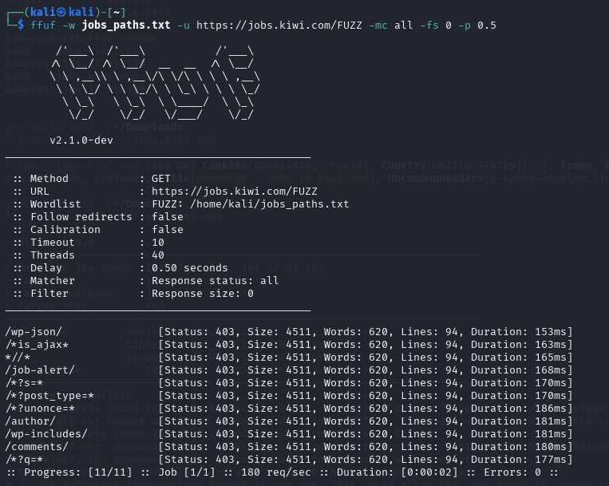  
Ffuf was used to test if any disallowed paths from robots.txt on jobs.kiwi.com were accessible. The scan filtered out empty responses and checked each path for access. According to the screenshot above, all paths returned 403 errors, meaning access is restricted and no unintended exposure was found.

* Automated Discovery of URL Parameters - Paramspider

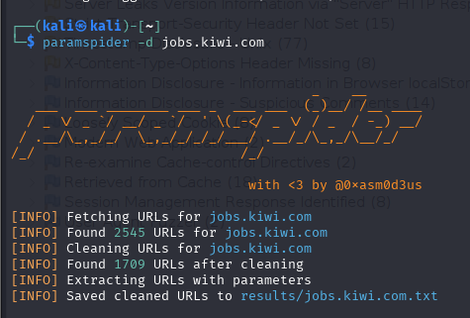

To identify hidden or potentially exploitable URL parameters, the tool ParamSpider was run against jobs.kiwi.com. The scan discovered 2,545 URLs, which were then cleaned down to 1,709 unique entries. From these, 683 URLs containing parameters were extracted for potential further testing of vulnerabilities such as XSS, SQLi, or open redirects.

* SSL/TLS Strength testing – sslscan (Figure 4.2D)

SSLScan was used to test the SSL/TLS configuration of jobs.kiwi.com. It supports modern protocols TLS 1.2 and TLS 1.3, while older versions like SSLv2, SSLv3, and TLS 1.0/1.1 are disabled.

The server is not vulnerable to Heartbleed, supports TLS Fallback SCSV, and has session renegotiation disabled. Strong cipher suites are used, including those with ECC curves like x25519 and secp256r1. The certificate is valid and signed with the ecdsa-with-SHA384 algorithm.

* Web Application Spidering - Zaproxy (Figure 4.2E - 4.2F)

Based on figures 4.2D and 4.2E, the next scan we did was with Zaproxy. On Zaproxy, we were able to explore the site’s available pages using both the traditional spider and the AJAX spider tool. By doing so, we can both crawl through the site by following links to build a page map, and crawl through JavaScript heavy applications like React.js if any.

Based on the results obtained as seen in the screenshots above, there were no major alerts that could be exploited. Furthermore, by looking through the spidered pages, we realised that the domain does not include login functionality or user-specific access. Hence, this indicates that deeper authentication-based testing such as IDOR or session hijacking was not possible to be tested.

## 4.3 Manual Application Testing

* Inspecting Burpsuite Requests

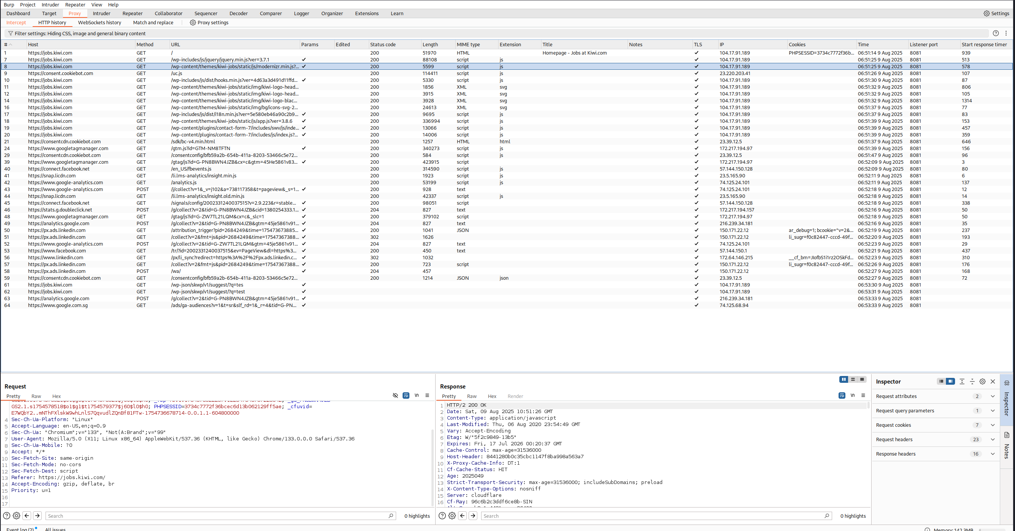

Burp Suite’s proxy feature was used to capture and inspect HTTP requests while interacting with jobs.kiwi.com. This allowed visibility into the site’s asset loading, endpoint structure, and cookie handling behaviour. Most captured requests were for static resources such as JavaScript, CSS, and SVG files, with occasional API calls to third-party services like Google Analytics and LinkedIn.

The inspection also revealed session cookies being set with attributes such as HttpOnly and Secure, although some cookies lacked the SameSite flag. There also were no obvious exploitable inputs that we could find while browsing through the requests.

* Testing Search Query (Figure 2.3A - 2.3C)

During manual testing, the search functionality at jobs.kiwi.com was observed to accept input through a parameter (q=) in the request url. After this request is sent in the response seems to come from Google Tag Manager. This can be seen in Figure 2.3A.

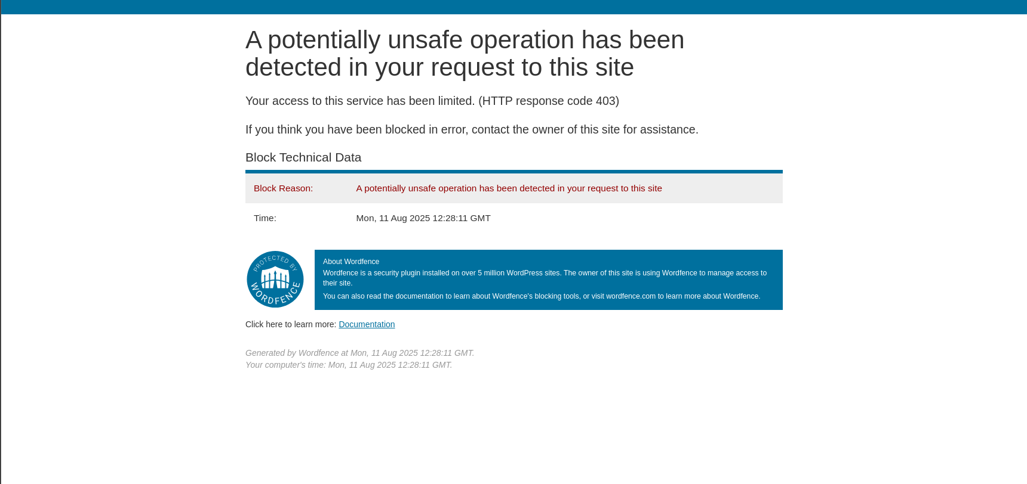

Knowing this, we submitted basic XSS and SQLi payloads into the search function, such as “<script>alert(“test”)</script>” and “ ‘ OR 1=1;”. However, there is input sanitisation which prevented us from doing so, as seen in Figure 2.3B. Furthermore, we are brought to an external page as seen in the screenshot above where we are told that our access to the site has been blocked by WordFence.

Hence, we tried to bypass input sanitisation by altering the requests in Burpsuite as well, as seen in Figure 2.3C and 2.3D. However, we were also met with a HTTP 400 error code for a bad request. This means that XSS and SQLi is prevented on the website.

* Cross-Origin Resource Sharing (CORS)

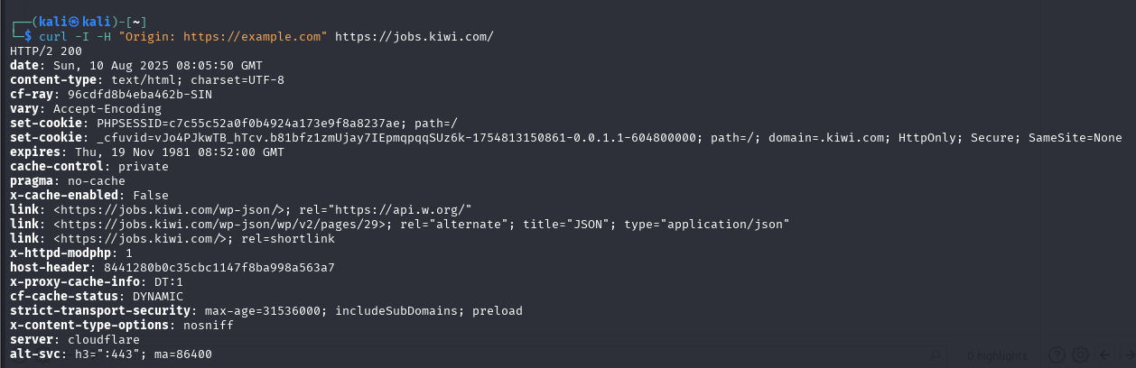

To check for potential Cross-Origin Resource Sharing (CORS) misconfigurations, we manually sent requests to jobs.kiwi.com with a forged Origin header using cURL. The server’s HTTP response did not include any Access-Control-Allow-Origin or Access-Control-Allow-Credentials headers. This indicates that CORS requests are not permitted and there is no apparent CORS misconfiguration on the tested endpoint.

As such, we were unable to find any potential vulnerabilities on the jobs.kiwi.com domain, since there is proper sanitisation which prevents XSS and SQLi, proper configuration to prevent CORS, and through our automated scans, we were unable to find any vulnerabilities as well to exploit. Hence, there will not be a “Potential Findings” section for this domain.

# 5 Business Story:

## 5.1 Business Owner (Javen)

As a business owner, the first priority is to ensure that our services remain available, trustworthy and secure for all customers. This means that every customer should have access to their data at any time, and their data should only be handled by both the company and the user, and not for anyone else. As such, any disruption to operations through cyber attacks, or data breaches could be detrimental to the reputation and the operations of the business, since these disruptions could lead to a loss in revenue and reduced customer trust.

Based on the penetration testing results obtain in the sections above, I was able to see that our systems have strong security in many areas. For example, we have good input sanitisation, and security measures that prevent attacks such as XSS or SQLi, especially in our hiring site, jobs.kiwi.com. However, I have also note d that there are vulnerabilities that could pose a threat to our other operations in our main website as well as our B2B platform.

Firstly, the most biggest security risk that was found was session hijacking through the use of a stolen su_access_token in our main website, [www.kiwi.com](https://www.kiwi.com). Based on the report, an attacker is able to gain full access to a logged in user’s account if they are able to gain access to their su_access_token. If they do, the attacker is able gain access to the user’s session, bypassing all forms of authentication to see personal information such as their credit card credentials or even their address. This security risk poses a major threat to our company because this strongly violates Confidentiality in the CIA triad. As such, if a attack like this was to happen and word gets out, such an incident will definitely harm the image of our company, and also cause our customers to move to more reliable and safer competitors. This will cause our company to take a hit in revenue, threatening our operations.

Similarly, the report has also identified other issues such as refresh token replay in our main domain. In our B2B platform, CORS misconfigurations and missing Content Security Policy headers has also been found. Although there is no confirmation that these issues are legitimate, these issues could be stepping stones to cause major losses in our business. For example, refresh token replay could lead to session hijacking, CORS misconfiguration could lead to data loss, and missing CSP headers could result in Cross Site Scripting attacks. Hence, it is important for these issues to be remediated quickly, to ensure that these minor problems do not lead to major data breaches, and causing damage to our business operations.

By understanding the risks found in the report, as a business owner, I will be able to make better business decisions. This means allocating more budget for immediate remediation of risks identified, based on the recommendations provided to us by the report. Only by addressing these issues in the report will we be able to reduce the likelihood of business disruptions, protect our users’ trust and to safeguard our domain as a whole.

## 5.2 Chief Security Officer (Joel)

As the CSO of Kiwi.com, my responsibility is to review the recommendations provided in the report, assess its impact, and oversee its implementation to strengthen our overall security. The report’s most critical recommendation addresses a session hijacking vulnerability in the su_access_token authentication cookie mechanism, which could allow the attackers to take control over an account with a stolen valid cookie, without the need for the victim’s credentials or two-factor authentication. The recommendation to overcome this is something that is important to prevent account hijacking.

Some other recommendations include the strengthening of access control mechanisms, enforcing cross-device session termination, tightening CSP rules and restricting access to sensitive endpoints that were found in robots.txt enumeration. While some of these are preventative measures rather than responses that are exploitable, they are still important to reduce the chances of attacks happening, to prevent weaknesses from being used in other more complex attacks as stepping stones.

By following some of the report’s recommendations and remediations, such as implementing device-bound session tokens, enforcing complete logouts across all the different sessions, refining CSP directives and reducing unnecessary public endpoint exposure. Through this, we would be able to address the vulnerabilities while also improving the resistance to future attacks. If these changes are put in place, we would be able to have a safe and secure environment for our customers and our operations.

## 5.3 Chief Security Officer (Joel)

As the CSO of Kiwi.com, my responsibility is to ensure that our business operates in full compliance with industry security standards and regulatory requirements, while protecting our customers' privacy and trust. The test revealed that there was a critical session hijacking vulnerability in the su_access_token cookie, which allowed for full account access without the need for credentials or two-factor authentication (2FA). This violates the OWASP ASVS session management requirements, PCI DSS payment data protections and GDPR Article 32 on safeguarding personal data like passport numbers, billing addresses, and stored payment information. (Links in reference)

There were other findings, which include gaps in access control, weak cross-device session termination, permissive CSP configurations and exposure of sensitive endpoints via robots.txt. However, despite them not being immediately exploitable, they could be used as steps in more complex attacks.

By addressing our findings that were highlighted in the pentest report, and working on some of the recommendations, like said in the above CSO viewpoint, we would not only be able to solve the vulnerabilities, but also ensure that Kiwi.com’s systems, policies, security and practices which align with OWASP ASVS, PCI DSS, GDPR and other relevant standards.

## 5.4 Engineering lead (Wei Hong)

As engineering lead, my focus is on using the technical insights we have obtained from this penetration testing to ensure that our team members are educated on the security risks so that i can promote a culture of vigilance. While the report highlights several critical and medium severity issues, this also gives us an opportunity to strengthen our secure coding practices, review some architectural issues and standardise some defensive measures across all domains.

The findings, such as the session hijacking through stolen authentication tokens, refresh token replay, absence of anti CSRF tokens, CSP and CORS misconfigurations in certain forms show the importance of embedding security into every stage of our software development lifecycle. Measures such as the implementation of token invalidation policies, setting strict CSP directives and introducing CSRF protection need to become a part of our standard engineering practice, rather than having reactive fixes.

With these findings, this report can be used as a learning tool for the team. By walking through each vulnerability and its root cause and the fix for it, our engineers can not only understand what to do, but also why it matters. Regular security focused reviews, automated scanning tools and clear internal coding guidelines will help maintain these standards across the projects.

Additionally, a new secure development training as part of onboarding for the new engineers will be implemented, ensuring that security awareness is ingrained from the start. By treating the insights from this report as a foundation for future improvements, we can build a culture where secure coding is second nature, where vulnerabilities are caught early and our systems are consistently resilient against evolving attack methods.

## 5.5 Engineering lead (Darrius)

As the engineering lead I need to ensure that all remediation strategies from the pentest report are taken into consideration and implement efficiently and properly. Remediation efforts should be done in order of the highest severity vulnerability to ensure minimal business impact.

Session hijacking should be the first vulnerability we address, and this can be done through binding authentication token to devices or IPs. If the device IP does not match the session table, their request will be rejected, and a logout will be initiated. This helps to ensure that authentication tokens cannot be reused. Multi-factor authentication can also be implemented to ensure that even if an authentication token has been stolen, it requires an OTP or a form of verification to authenticate the process. Notifications can be sent out when any actions are being initiated such as payment process or when access to the account details which consists of passport information.

For refresh token replay vulnerability, token rotation expiry times can be implemented to minimise the exploitation window where tokens can be reused. This is done through invalidating the old authentication token immediately and replacing it with a new one whenever it is used to request a new access token and storing the token state in the server side to reject any replay attempts.

CORS misconfiguration can be resolved through restricting the allowed origins to only legitimate domains. This helps to ensure that only domains that are authenticated and approved can access the data. Whitelisting of domains can help to keep track of which domains are allowed, and Access-Control-Allow-Credentials should only be enabled for origins which are trusted to prevent any unauthorised cross-origin requests.

CSP headers should be introduced to ensure that the defence-in-depth strategy works efficiently and effectively. It should be introduced in report-only mode and enforced progressively so as to not disrupt other legitimate processes. The policy should use a whitelist to allow only trusted sources to execute content such as scripts, styles and other resources. Inline scripts should also be set to disallow to reduce the risk of any XSS attacks.

Overall, my role as an engineering lead is to ensure that these remediation strategies are being implemented properly. This is essential as it ensures business continuity and customer trust. By collaborating closely with the Chief Security Officer, we can ensure that the most effective remediation measures are implemented and tested allowing us to address all vulnerabilities which strengthens the overall security of the business web application.

# 6. Conclusion

This concludes the penetration testing of the bug bounty program posted by kiwi.com, at the link <https://hackerone.com/kiwicom>. All security issues discovered during our penetration testing exercise is analysed and described in the report, with proof-of-concept evidence as well as remediation recommendations.

Through our testing of publicly accessible functions on test accounts and values provided, our penetration test on the domain has revealed 5 medium to critical severity vulnerabilities. These vulnerabilities are mainly in broken access controls, or the failure of authentication and identification systems.

On the bright side, the overall security posture of all tested domains is strong. In all domains, there is strong input validation and sanitisation as well as suitable HTTP headers used in request and responses. These security features help to prevent potential vulnerabilities like CSRF, XSS or SQLi. This especially so in the jobs.kiwi.com domain, as our team was unable to find any vulnerabilities that could be exploited.

As such, our group recommends that Kiwi.com implement our proposed remediation measures to our potential findings. By doing so, it can make the web application even safer from major problems like session hijacking. With all these in place, we believe that Kiwi.com will be safer than ever from web application vulnerabilities.

However, do note that the testing is based on the research and knowledge of our group during the assessment window. Hence, our potential findings may not be exploitable vulnerabilities at all, but are nonetheless worth addressing, because our team feels that these points still pose a threat to the business’s Confidentiality, Integrity and Authenticity.

# 7. Appendix:

# 7.1 Figures for www.kiwi.com & auth.skypicker.com:

**Reconnaissance and Automated Scans:**

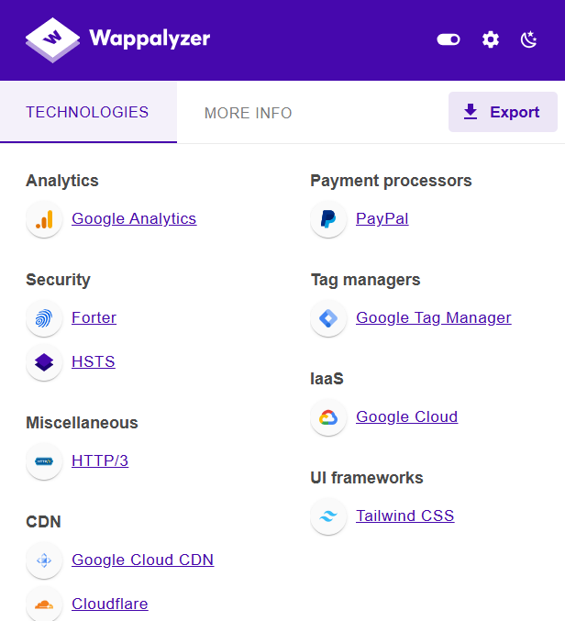

Figure 2.1A - Information from Google Extension, Wappalyzer

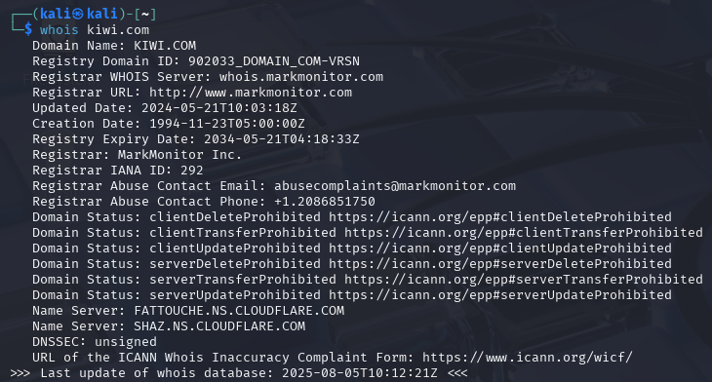

Figure 2.1B - Output of command “whois kiwi.com”

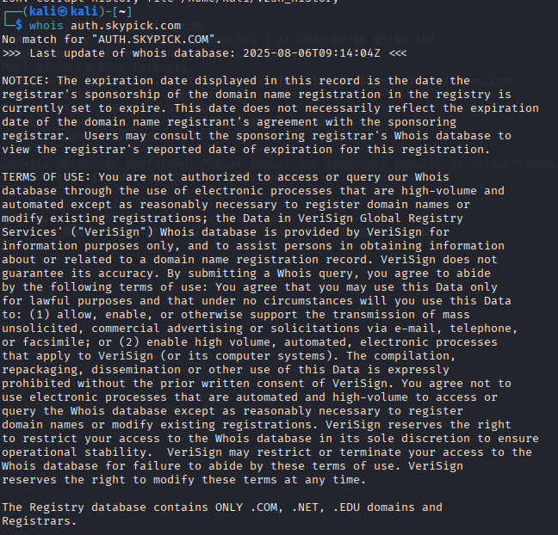

Figure 2.1C - Output of Command “whois auth.skypick.com”

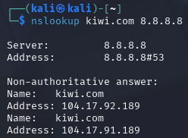

Figure 2.1D - Output of Command “nslookup kiwi.com 8.8.8.8”

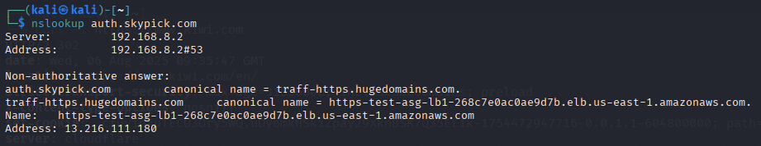Figure 2.1E - Output of Command “nslookup auth.skypick.com”

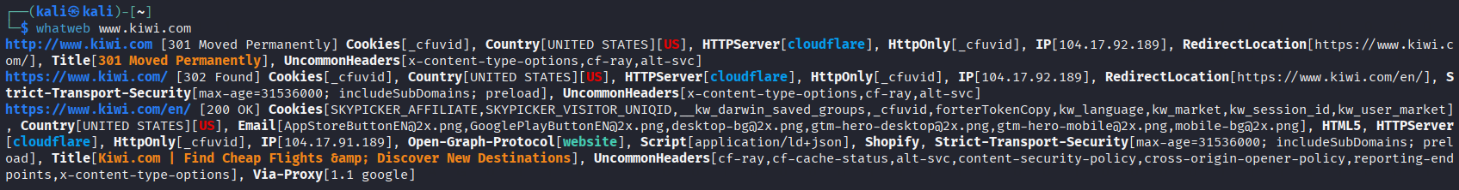Figure 2.1F - Output of Command “whatweb [www.kiwi.com](https://www.kiwi.com)”

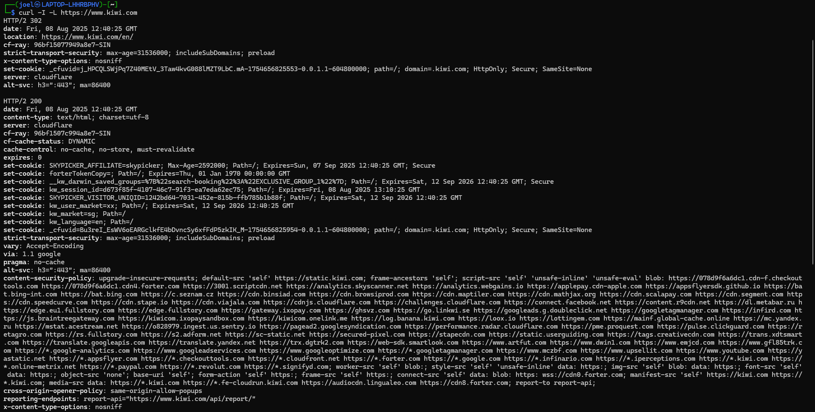Figure 2.2A - Fingerprinting using curl

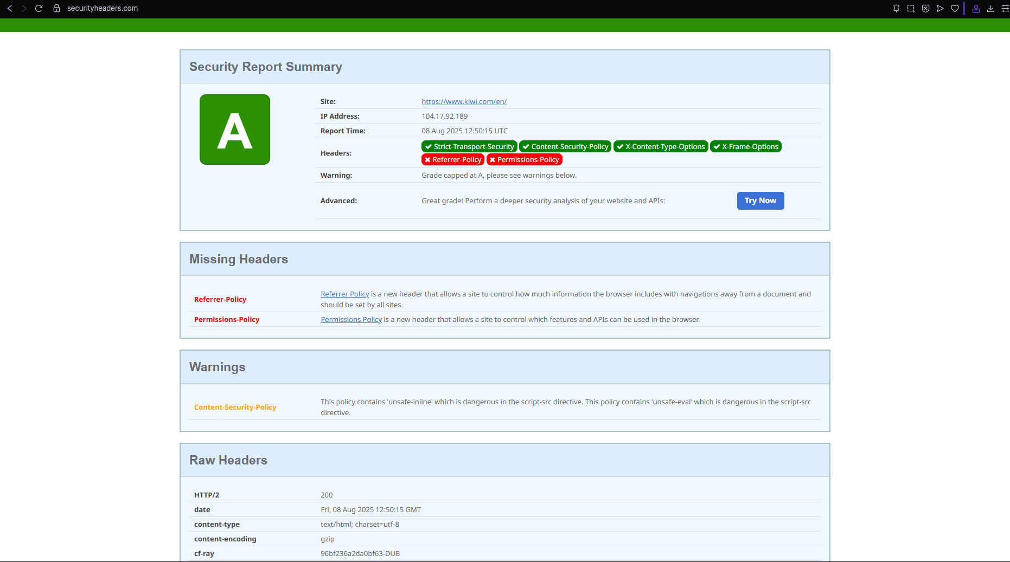Figure 2.2B - Fingerprinting using online website, [securityheaders.com](https://securityheaders.com/?q=www.kiwi.com&followRedirects=on)

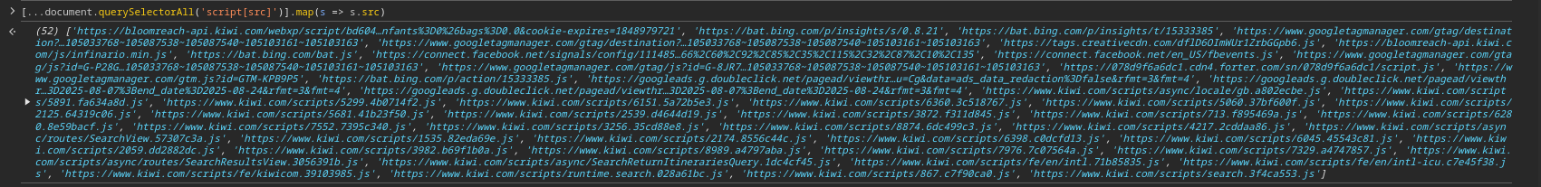Figure 2.2C - Dumping all scripts used by the domain using console

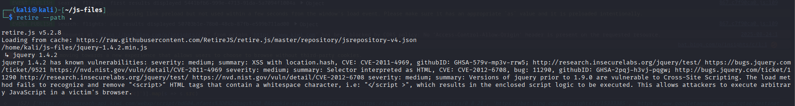Figure 2.2D - Retire.js output if there is a vulnerable JS library version in use

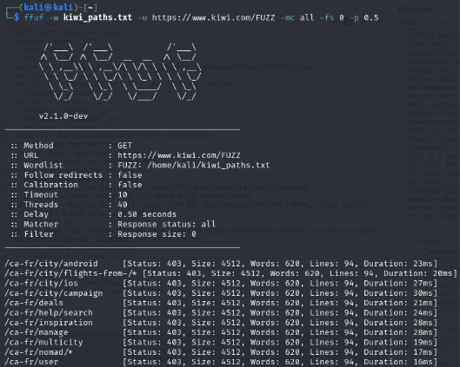

Figure 2.2E - Directory and Endpoint Validation from robots.txt

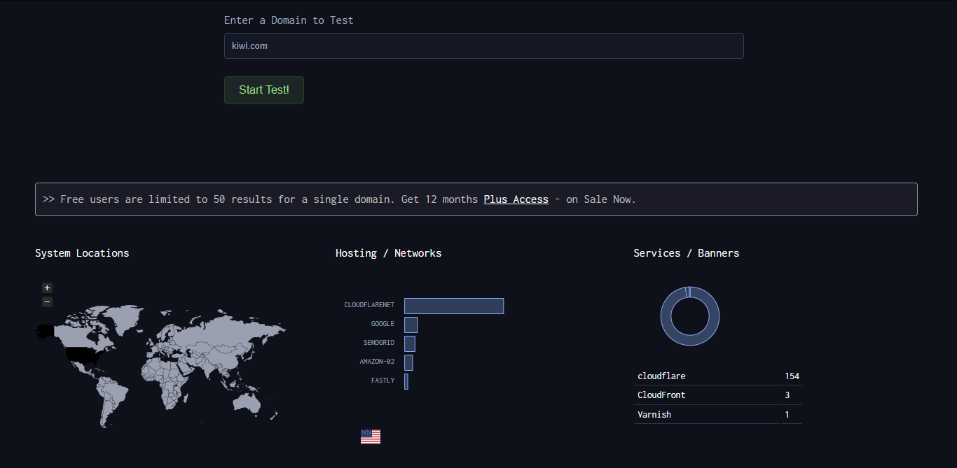Figure 2.2F - Subdomain & DNS Enumeration via DNSdumpster

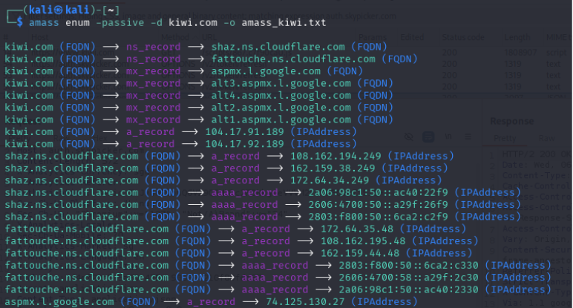

Figure 2.2G - Passive Subdomain Enumeration

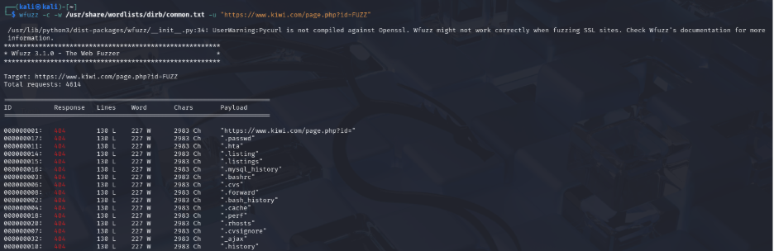Figure 2.2H - Parameter Fuzzing for Injection Points

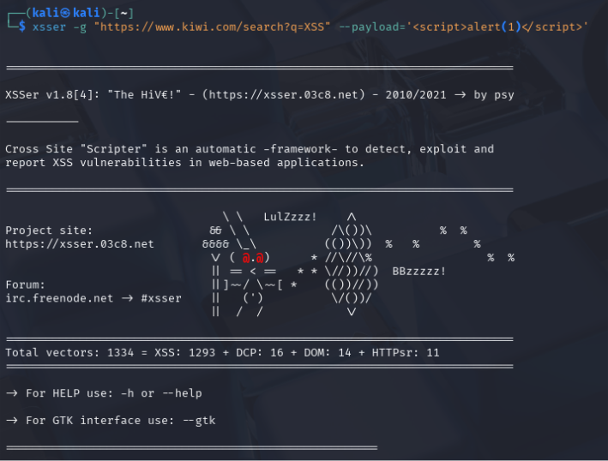

Figure 2.2I - Automated Cross-Site Scripting (XSS) Testing

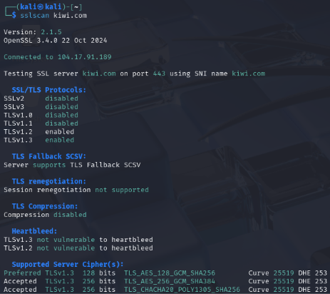

Figure 2.2J - SSL-TLS Strength Testing

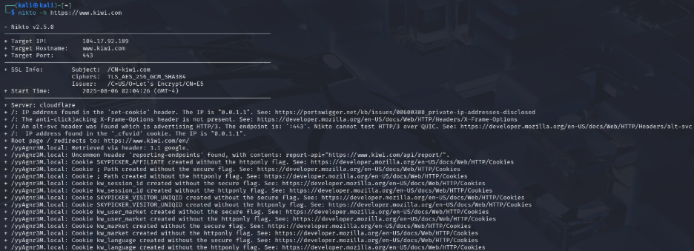Figure 2.2K - Web server vulnerability assessment

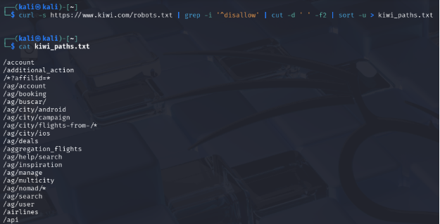

Figure 2.2L - Robots.txt Enumeration

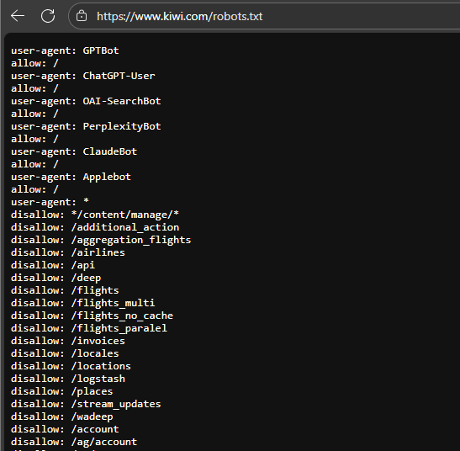

Figure 2.2M - Robots.txt

**Manual Testing:**

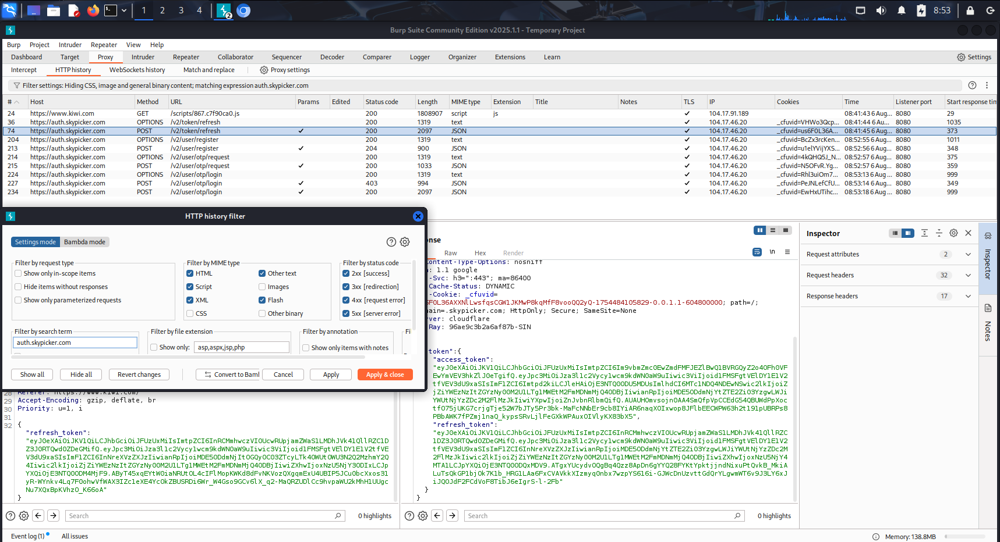Figure 2.3A - Filtering to find use of API

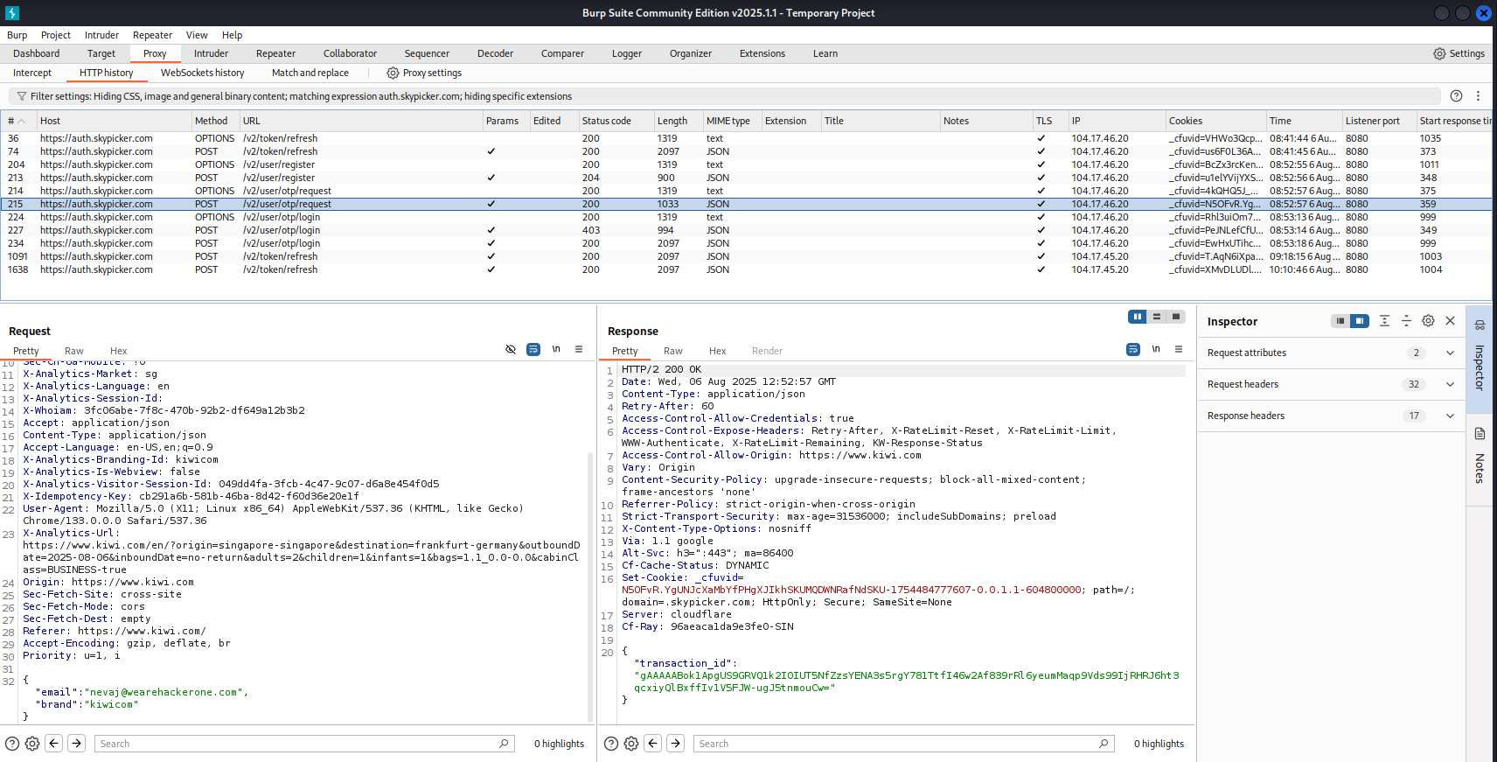Figure 2.3B - Receiving of Transaction ID, with valid email

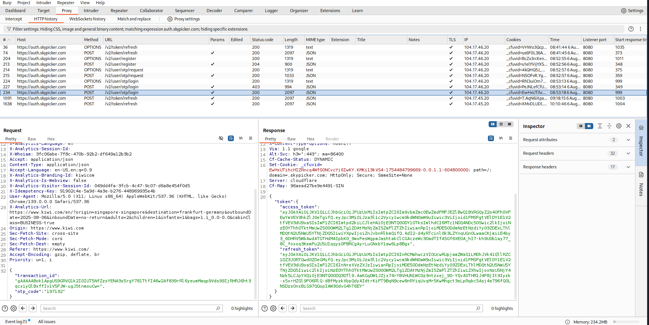Figure 2.3C - Receiving of access and refresh token with transaction id and OTP

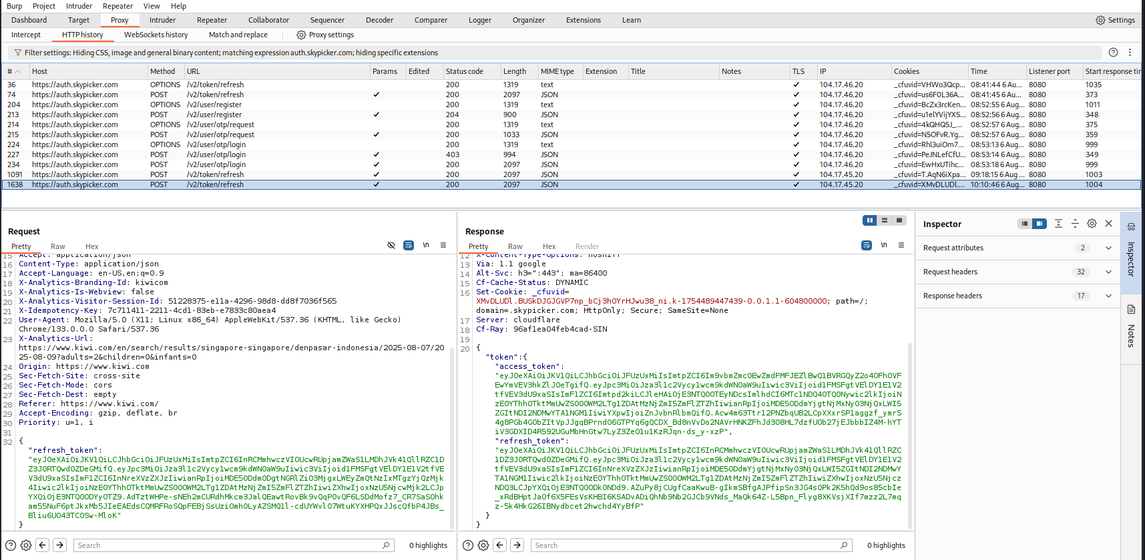Figure 2.3D - Receiving of access and another refresh token with refresh token

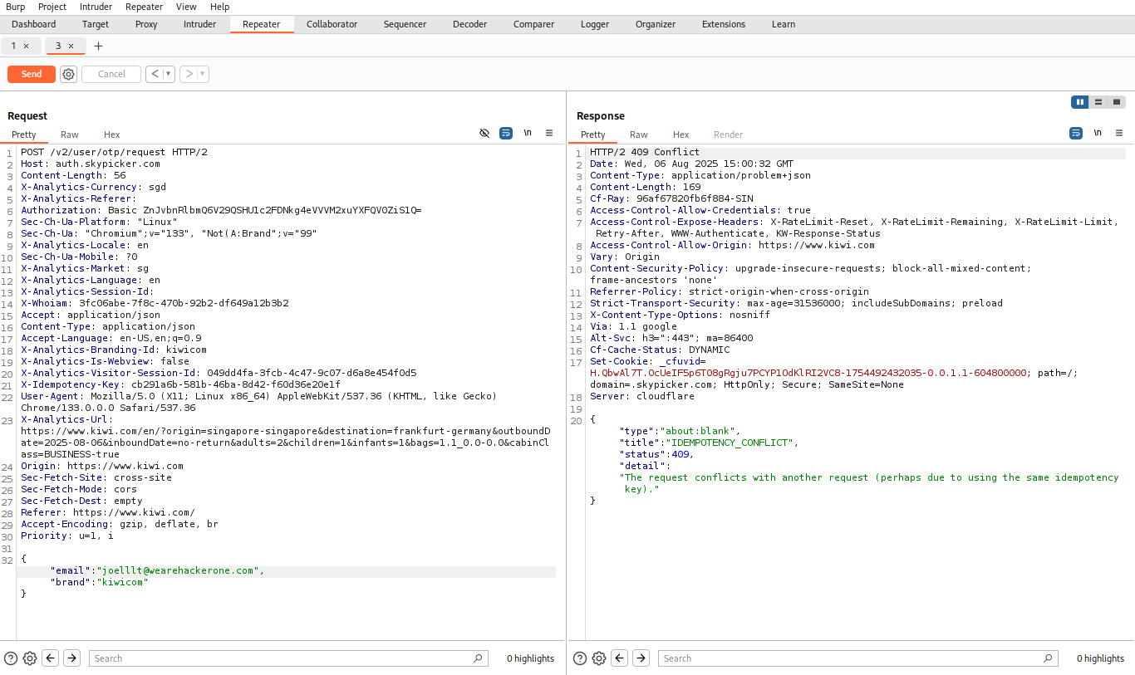Figure 2.3E - Replacing email with another user’s returns an error.

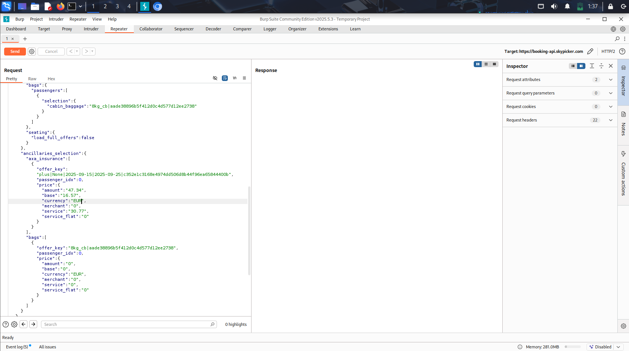Figure 2.3F - Before changing currency

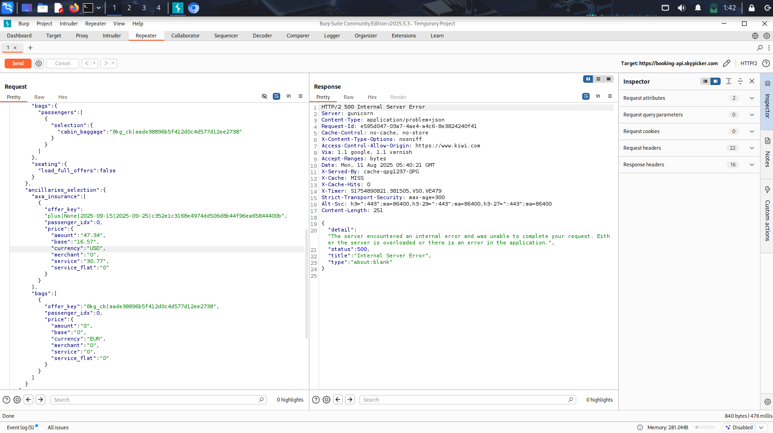Figure 2.3G - After changing currency

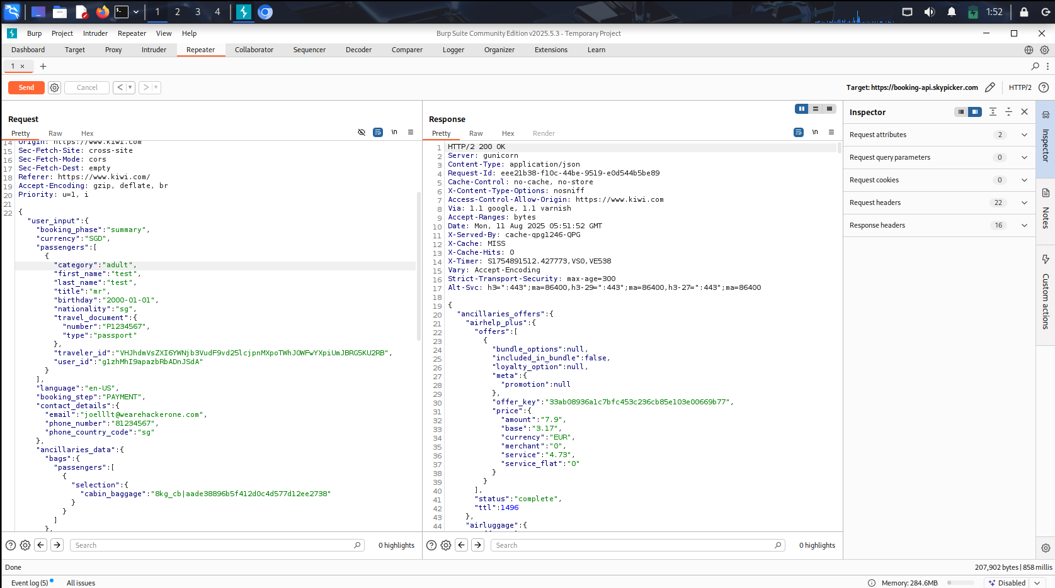Figure 2.3H - Before changing category

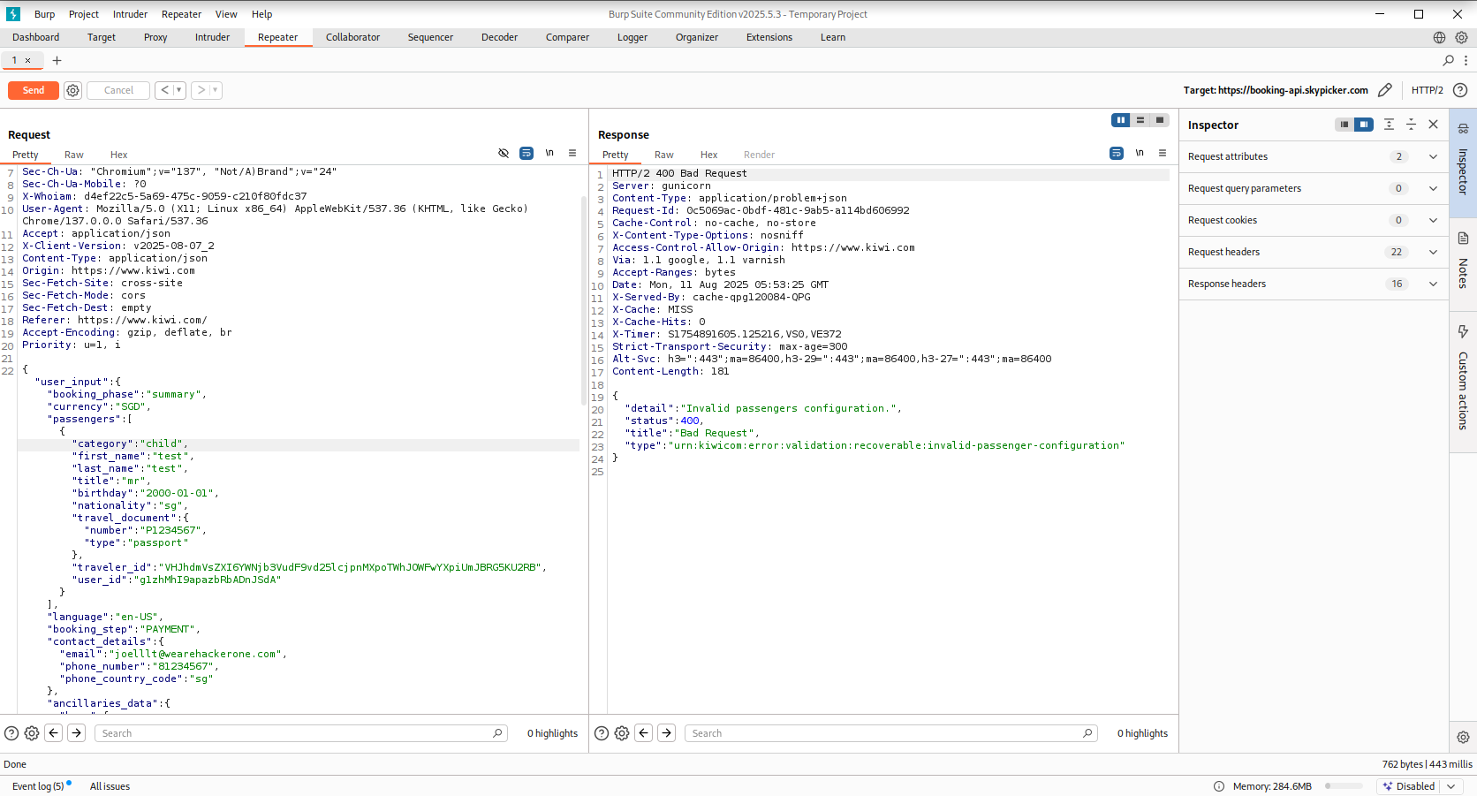Figure 2.3I - After changing category

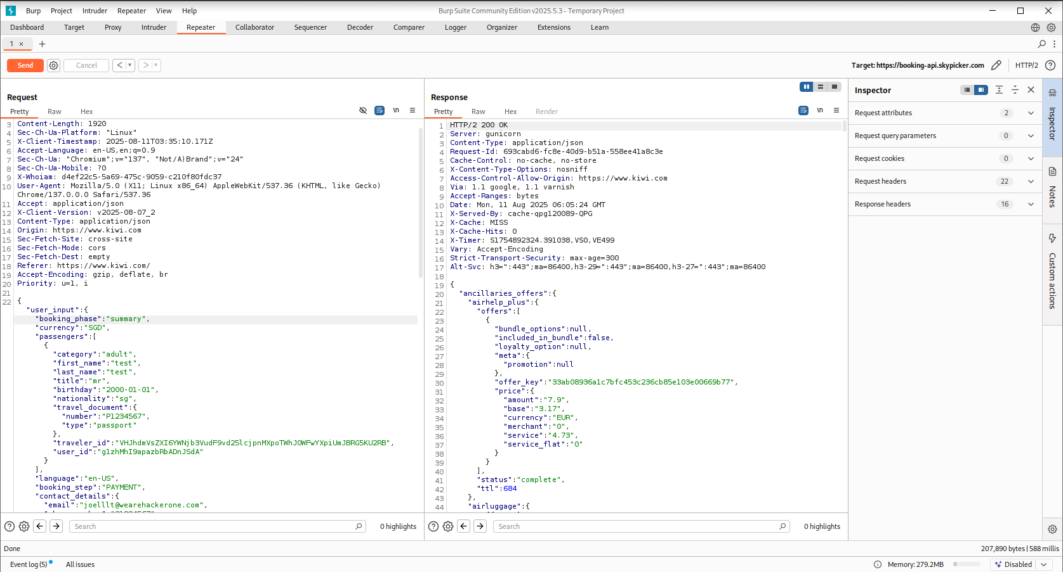Figure 2.3J - Before changing booking_phase

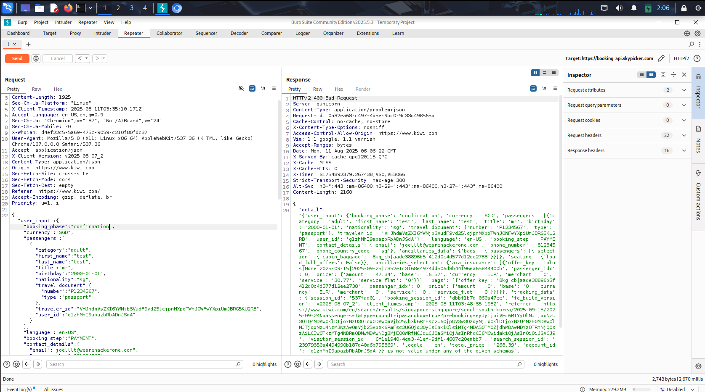Figure 2.3K - After changing booking_phase

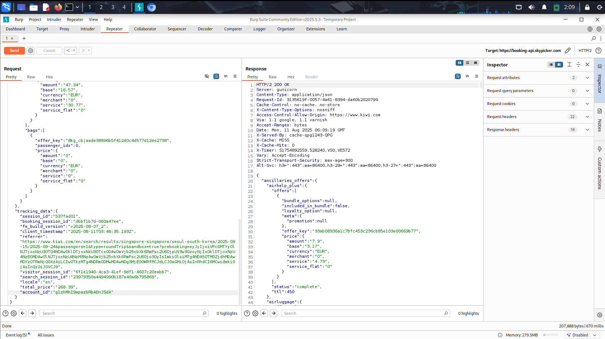Figure 2.3L - Before changing account_id

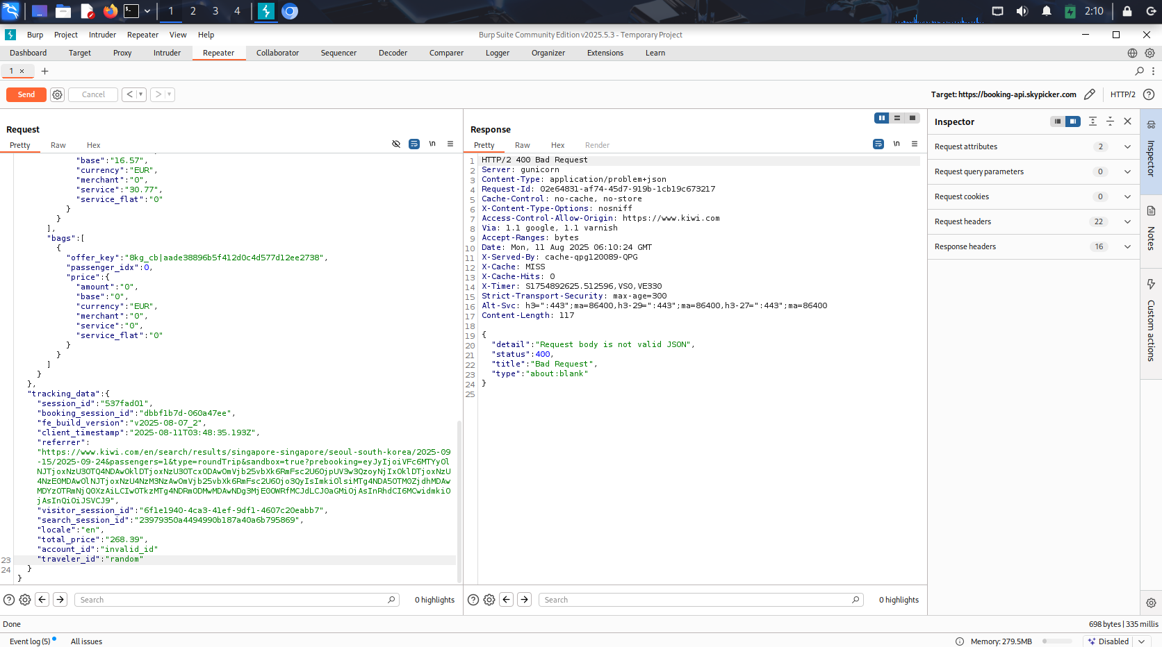Figure 2.3M - After changing account_id and adding traveler_id

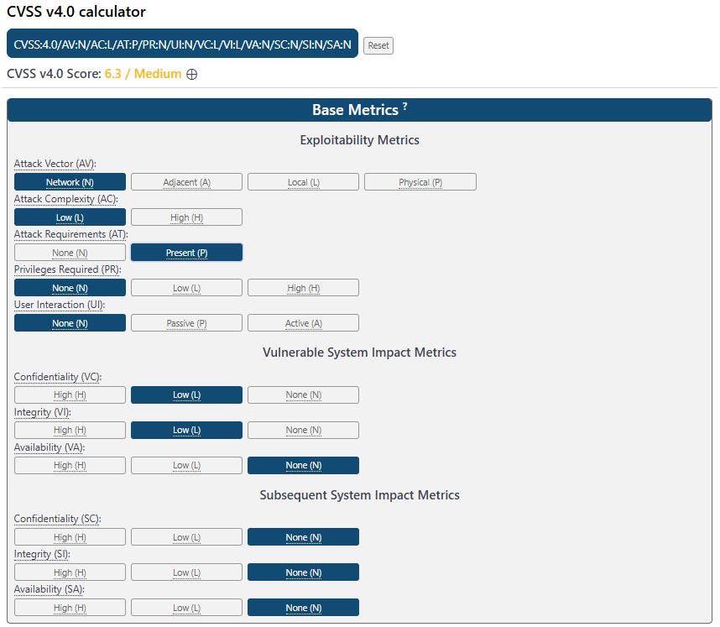Figure 2.4A - Calculation of CVSS for Refresh Token Replay Vulnerability

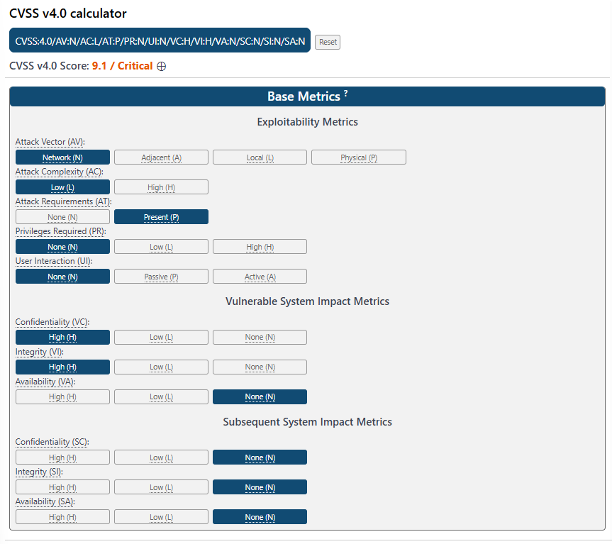

Figure 2.4B - Calculation of CVSS for Session Hijacking

# 7.2 Figures for tequila.kiwi.com:

### Reconnaissance:

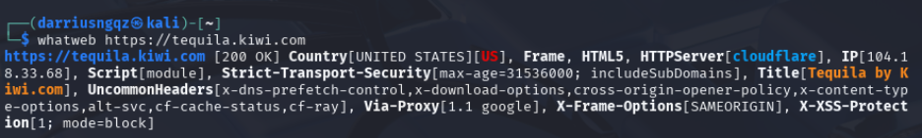Figure 3.1A - WhatWeb

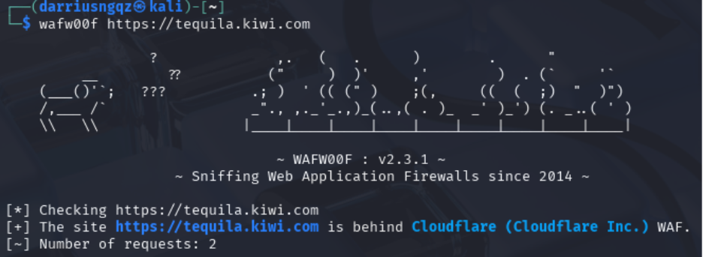Figure 3.1B - WafW00f

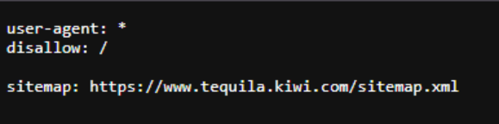Figure 3.1C - Robots.txt

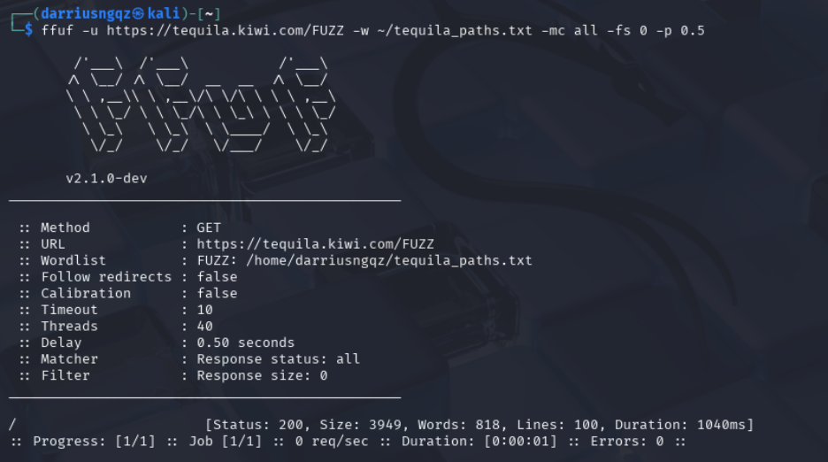Figure 3.1D - FuFF

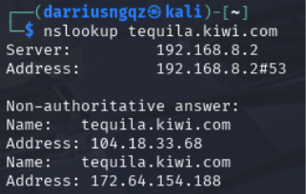

Figure 3.1E - nslookup

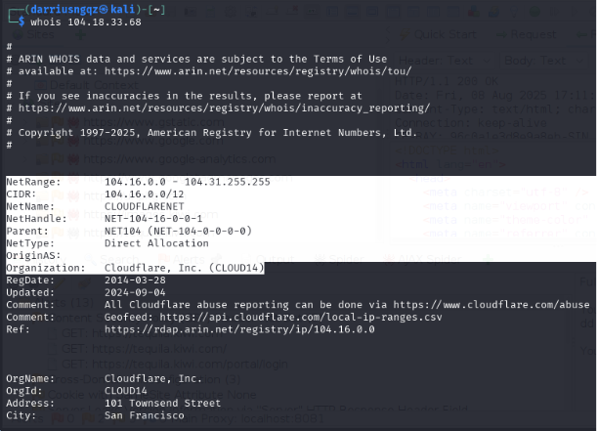

Figure 3.1F - Whois of tequila.kiwi.com’s Resolved IP Address 104.18.33.68

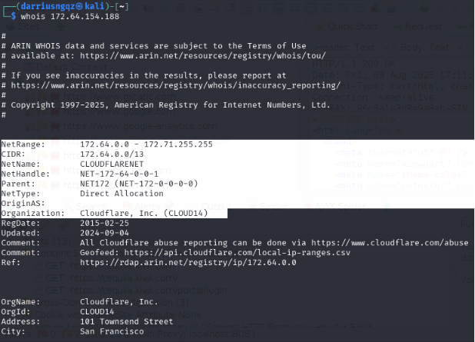

Figure 3.1G - Whois of tequila.kiwi.com’s Resolved IP Address 172.64.154.188

### Automated Scan:

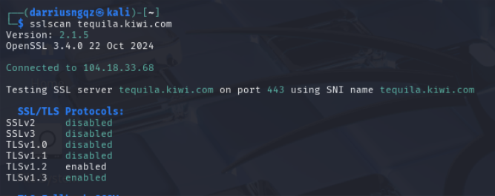

Figure 3.2A - SSL/TLS Protocols Enabled

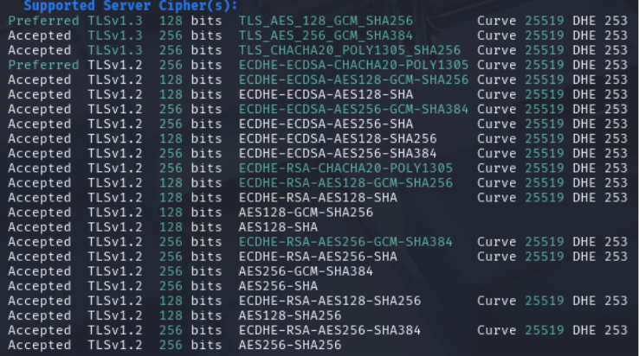

Figure 3.2B - Accepted Cipher Suites

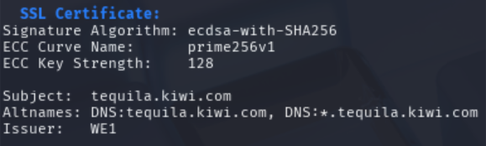

Figure 3.2C - Certificate Used

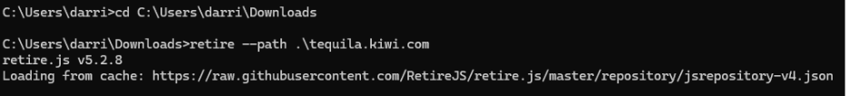Figure 3.2D - Retire.js

### Manual Application Testing:

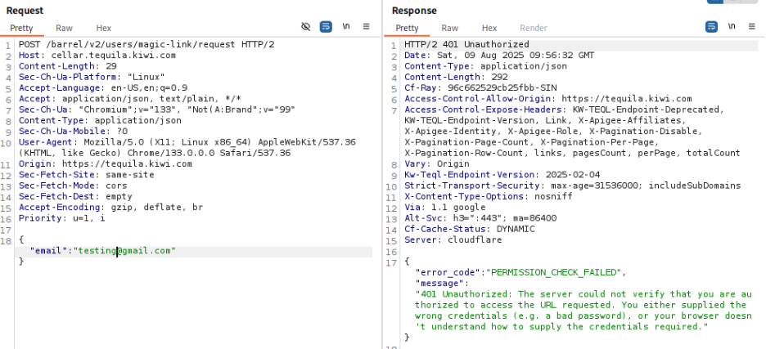

Figure 3.3D - Testing Email Input Field with Unauthorised Email

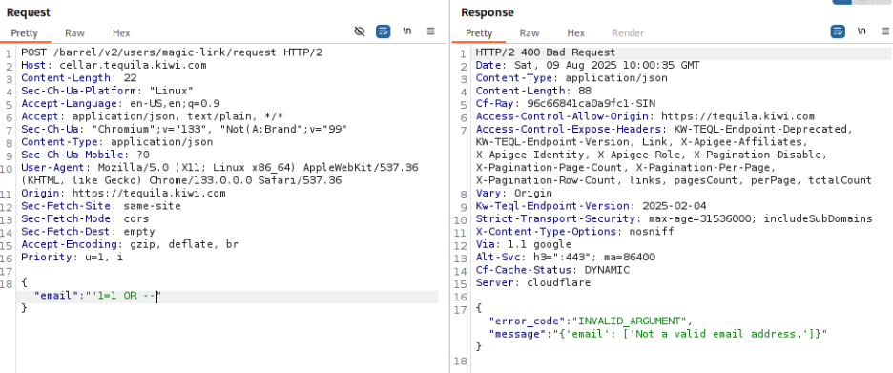Figure 3.3E - Testing Email Input Field using SQL Injection

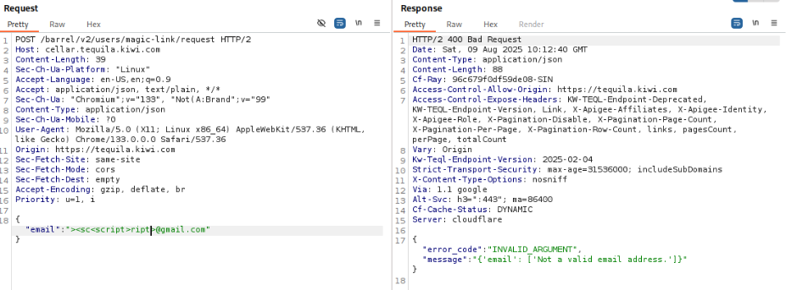Figure 3.3F - Testing Email Input Fields for XSS

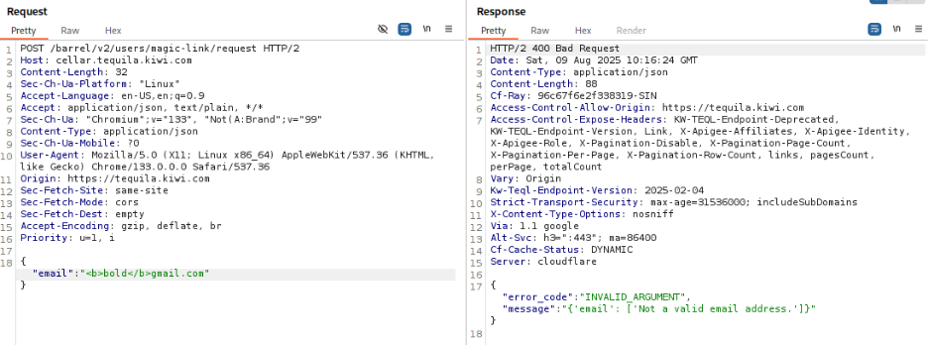Figure 3.3H - Testing Email Input Fields using HTML injection

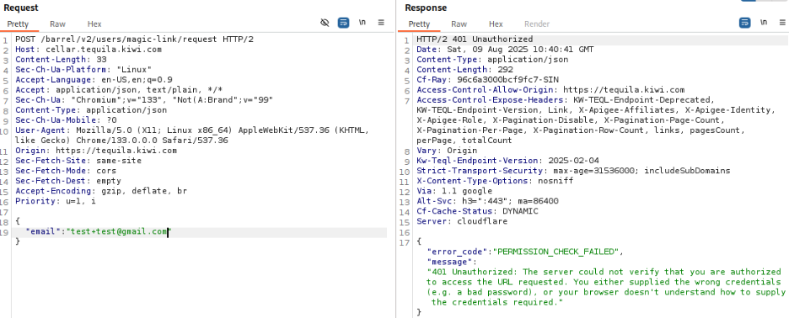Figure 3.3I - Testing Email Input Fields using Unusual Valid Emails

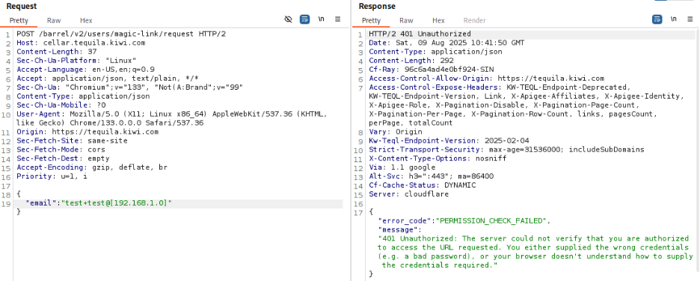Figure 3.3J - Testing Email Input Fields using Unusual Valid Emails

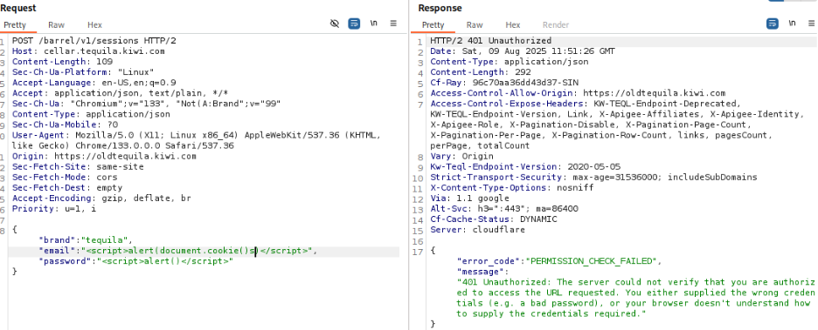Figure 3.3K - Testing Password-based Login Page for XSS

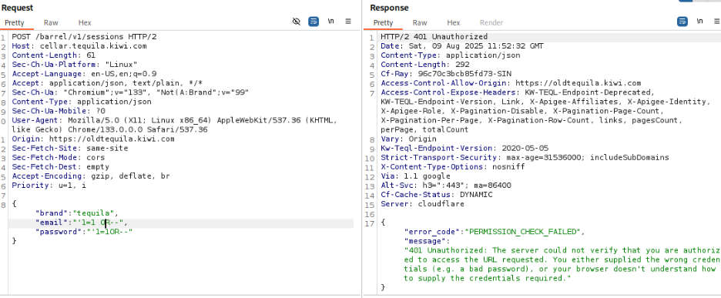Figure 3.3L - Testing Password-based Login Page for SQL injection

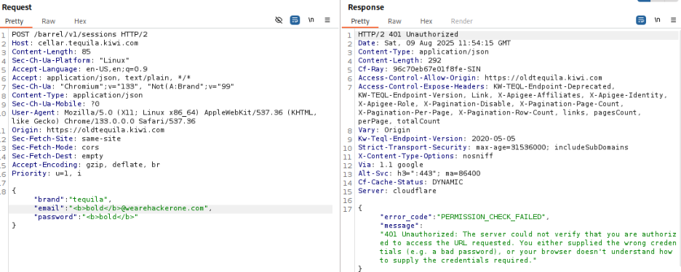Figure 3.3M - Testing Password-based Login Page for HTML injection

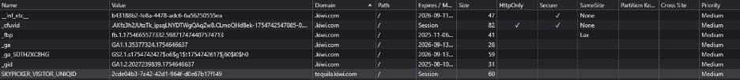Figure 3.3N - Cookies

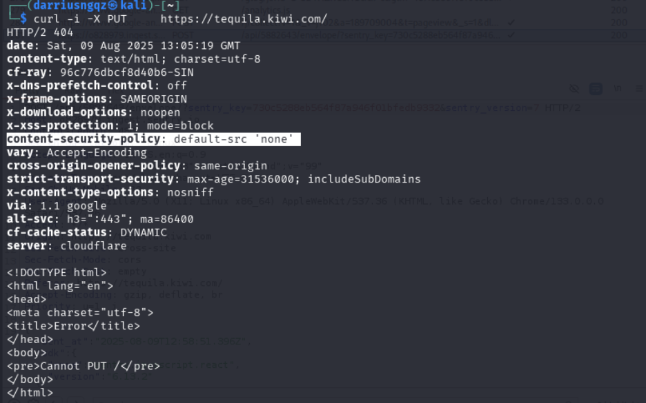Figure 3.3O - Method Tampering using cURL

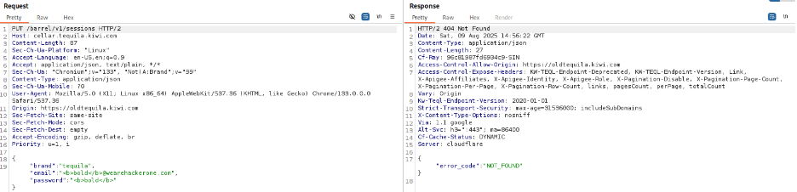

Figure 3.3P - Method Tampering PUT

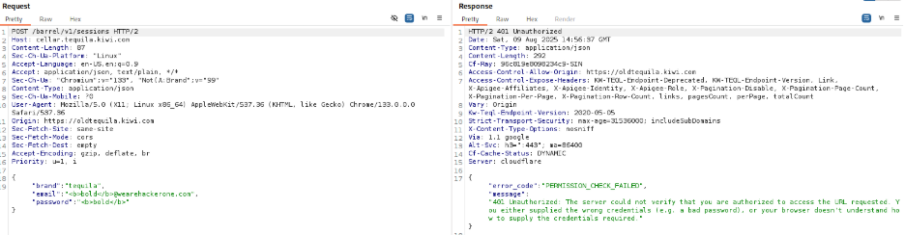

Figure 3.3Q - Method Tampering POST

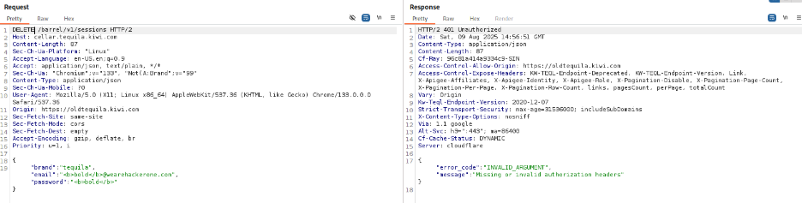

Figure 3.3R - Method Tampering with DELETE

### Potential Findings

#### Missing Content Security Policy (CSP)

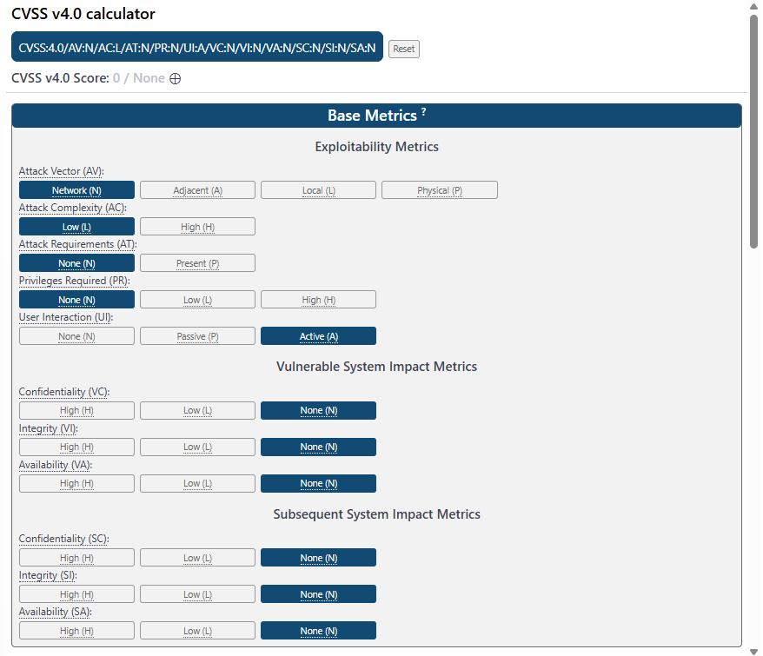

Figure 3.4.1.1 - Calculation of CVSS Score for Missing CSP (Without XSS)

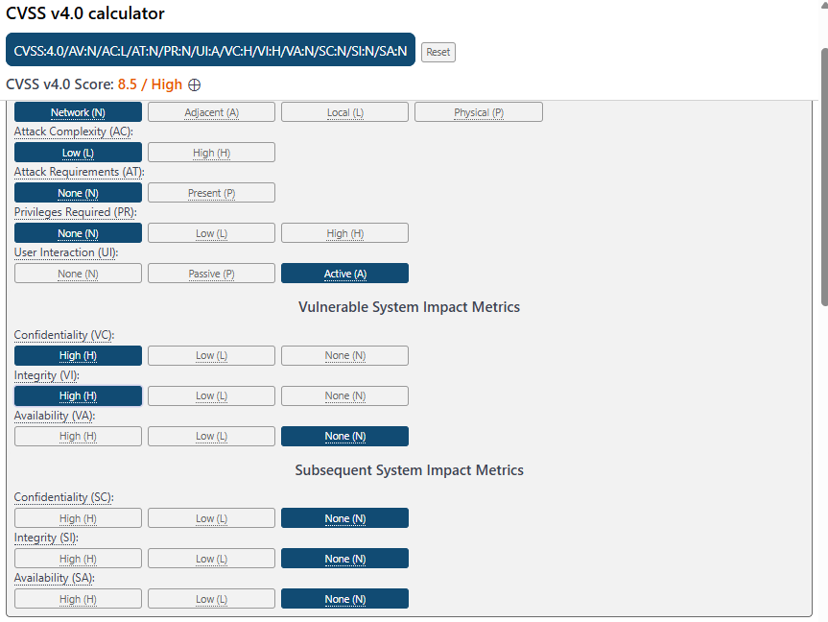

Figure 3.4.1.2 - Calculation of CVSS Score for Missing CSP (With XSS)

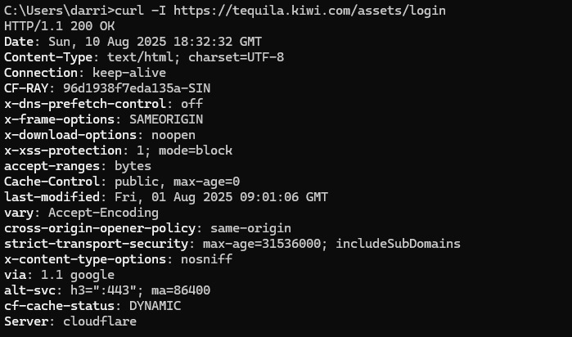

Figure 3.4.1.2 - Missing CSP in /assets/login Endpoint

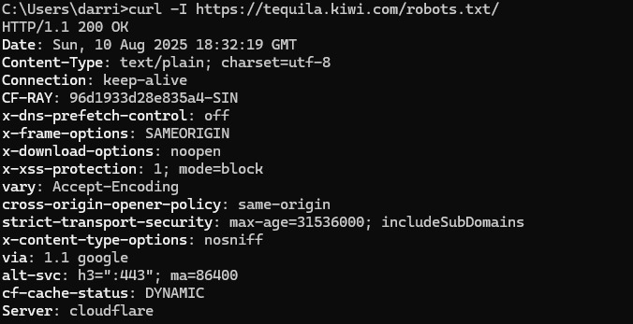

Figure 3.4.1.3 - Missing CSP in /robots.txt Endpoint

#### Cross-Origin Resource Sharing (CORS) Misconfiguration

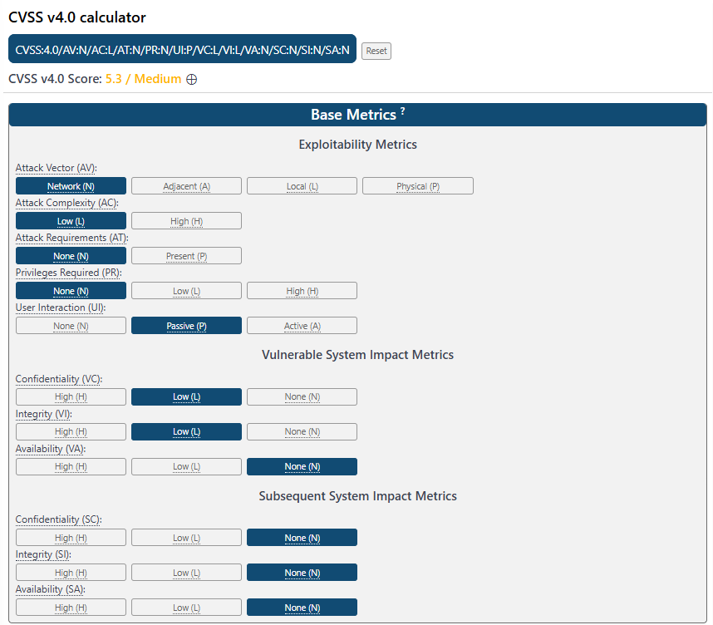

Figure 3.4.2.1 - Calculation of CVSS Score for Cross-Origin Resource Sharing Misconfigurations

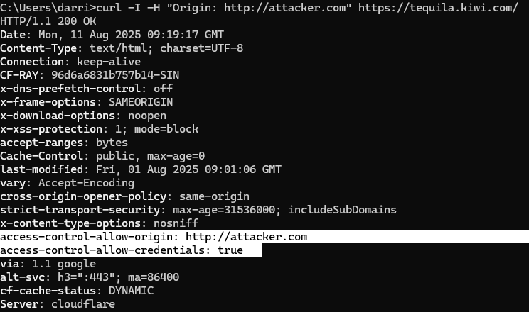Figure 3.4.2.3 - CORS Misconfiguration on Main Domain

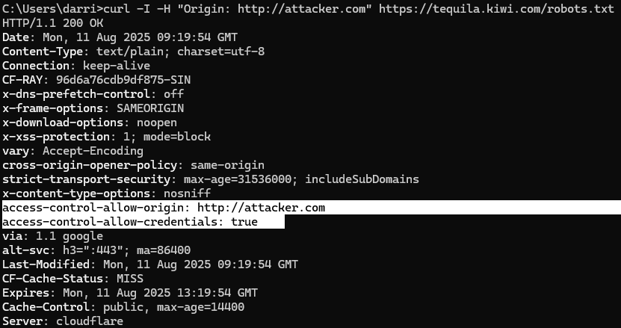Figure 3.4.2.4 - CORS Misconfiguration on /robots.txt Endpoint

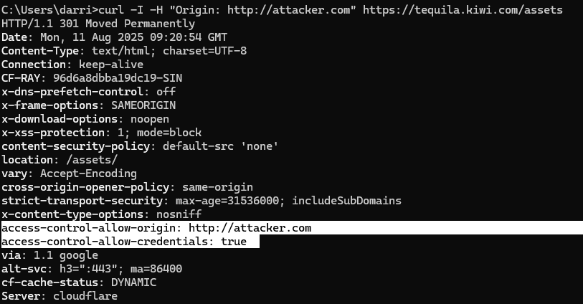Figure 3.4.2.4 - CORS Misconfiguration on /assets Endpoint

# 7.3 Figures for jobs.kiwi.com

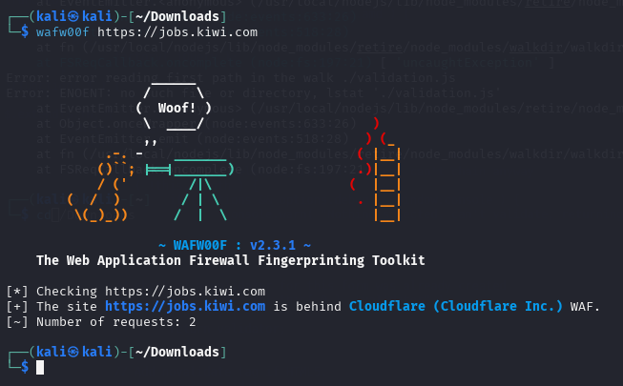

Figure 4.1A - Output of Wafw00f on jobs.kiwi.com page

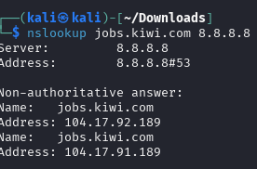

Figure 4.1B - nslookup on jobs.kiwi.com domain

Figure 4.1C - output of whatweb jobs.kiwi.com

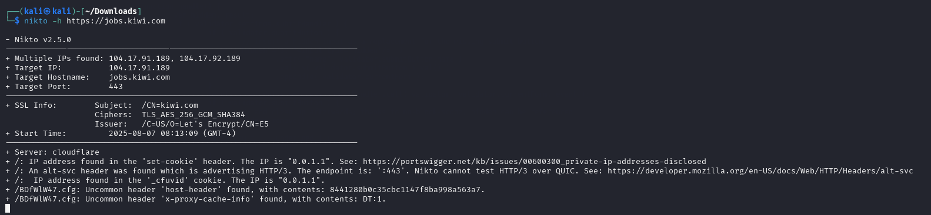Figure 4.2A - Output of nikto command on jobs.kiwi.com domain

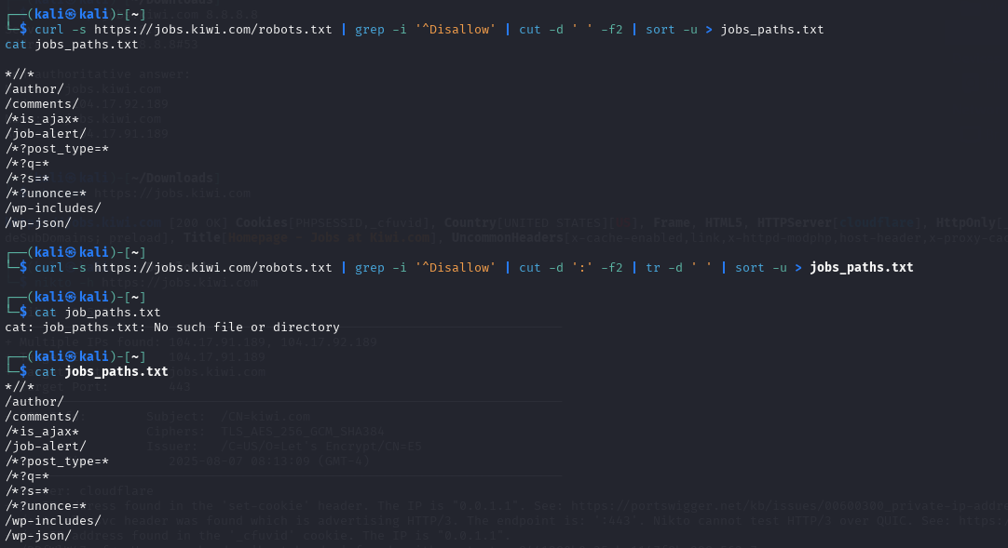

Figure 4.2B - Retrieving robots.txt file

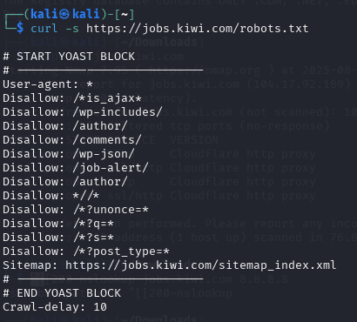

Figure 4.2C - Curling of the page

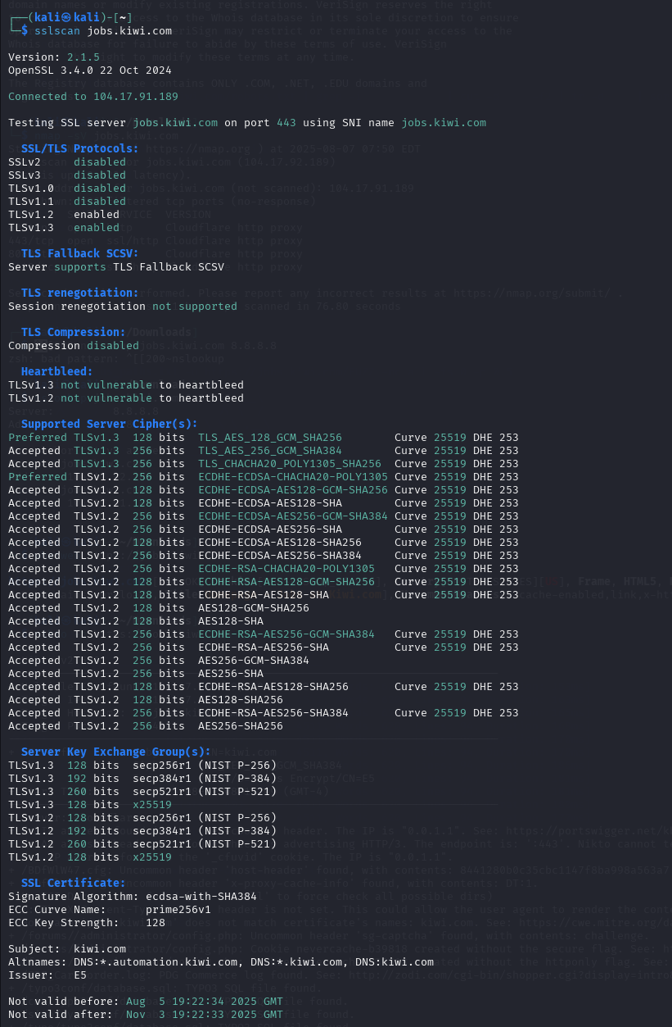

Figure 4.2D - sslscan on jobs.kiwi.com domain

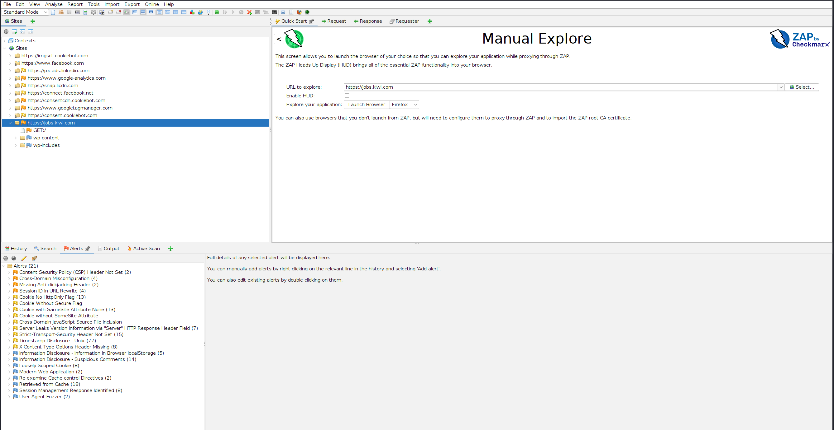Figure 4.2E - Results of Spider tool on Zaproxy

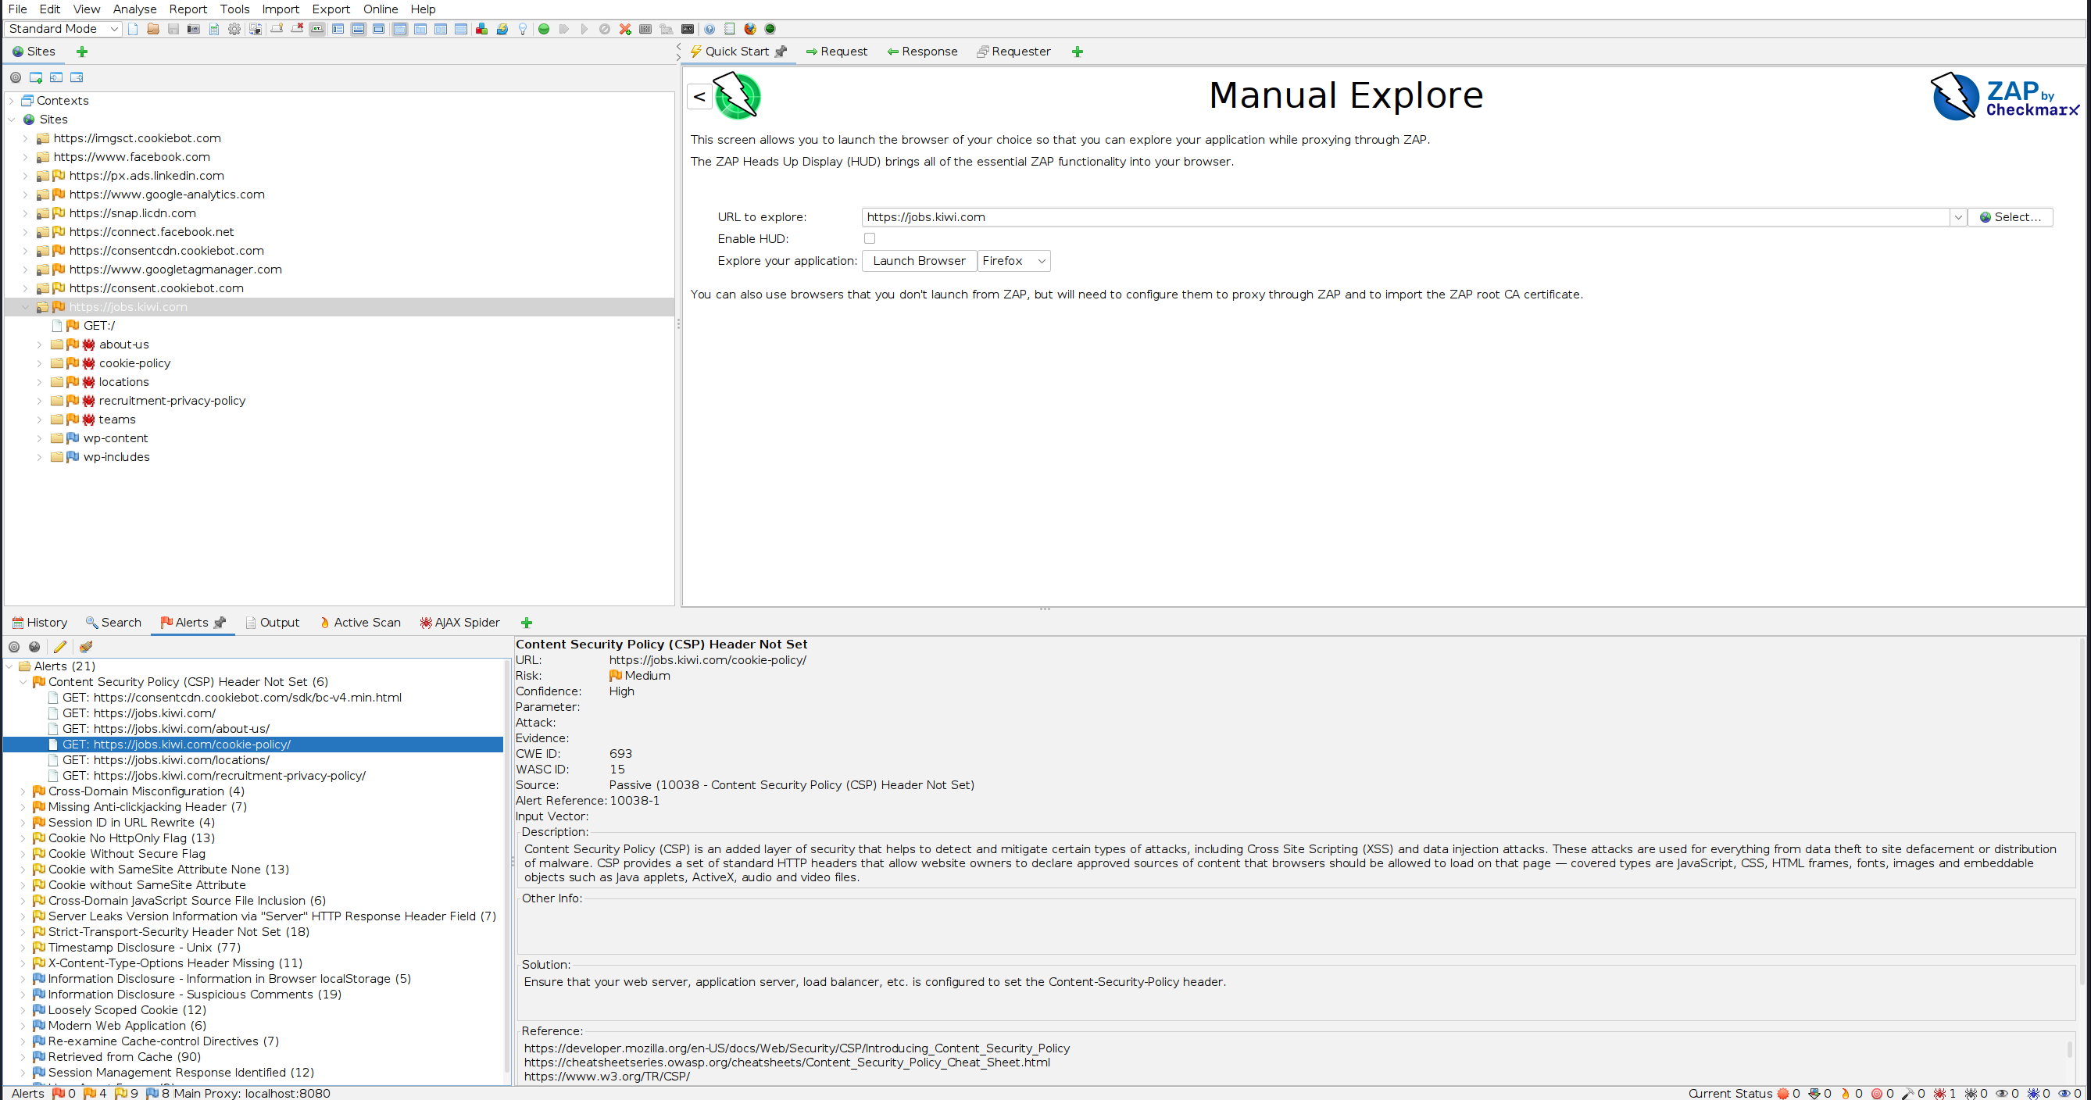Figure 4.2F - Results of Ajax Spider Tool on Zaproxy

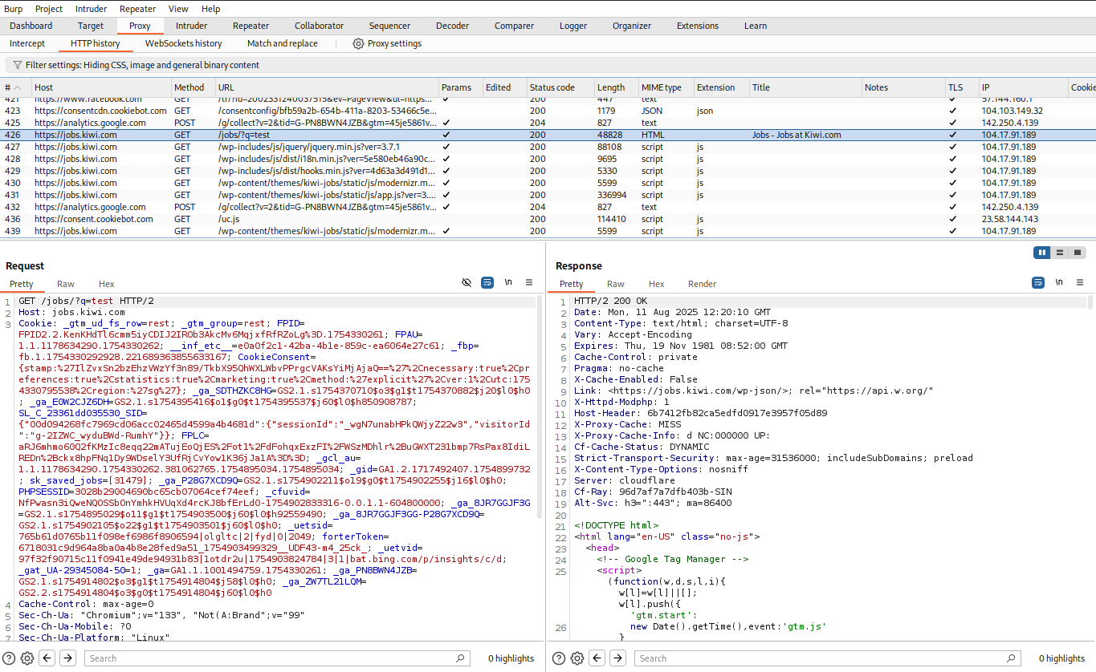Figure 4.3A - Request sent when typed into search bar

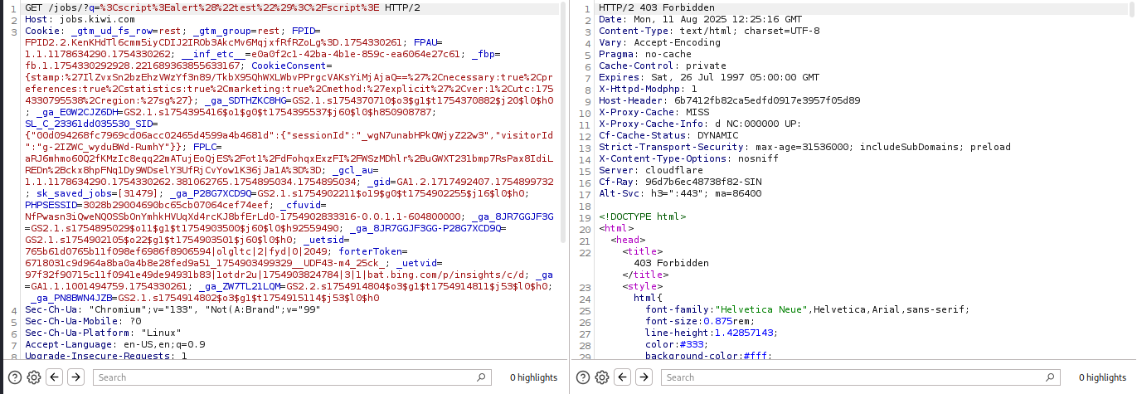Figure 4.3B - Input sanitisation for special characters, 403 Forbidden response.

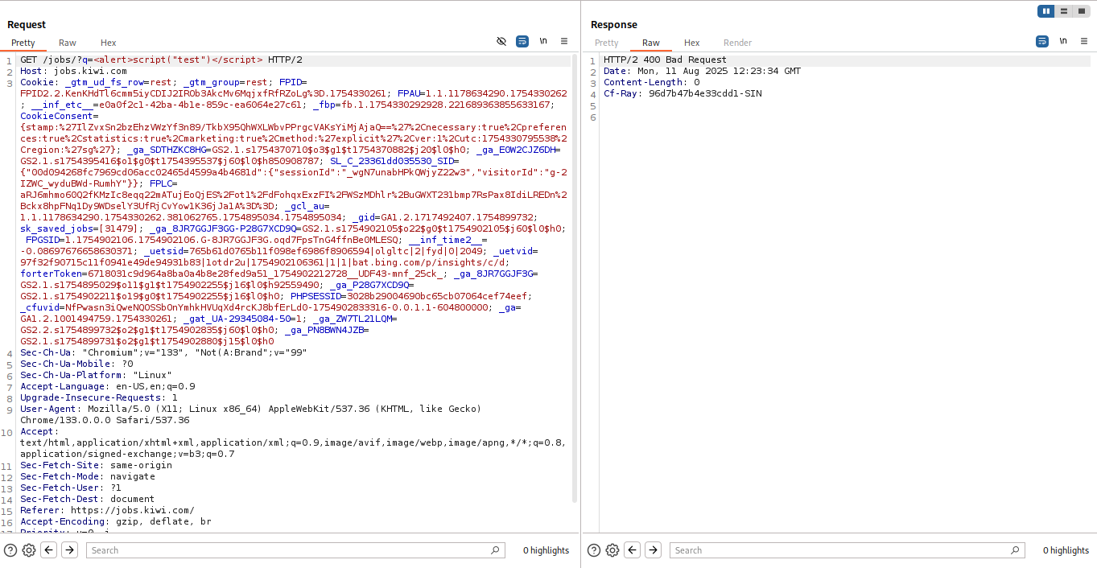4.3C - Altering Search Request with Burpsuite to test XSS

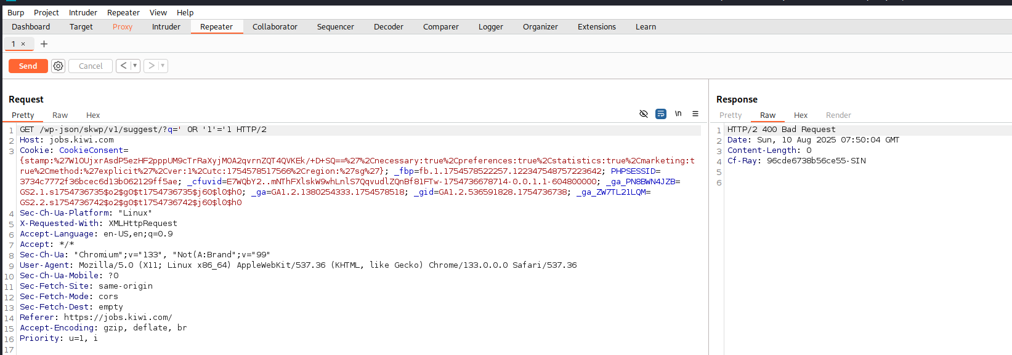4.3D - Altering Search Request with Burpsuite to test SQLi

# 8. References

OWASP Top Ten | OWASP Foundation. (n.d.). <https://owasp.org/www-project-top-ten>

What are Refresh tokens and how to use them securely | Auth0. (n.d.). Auth0 - Blog. <https://auth0.com/blog/refresh-tokens-what-are-they-and-when-to-use-them>

Find out what websites are built with - Wappalyzer. (n.d.-b). <https://www.wappalyzer.com/>

Nikto 2.5 | CIRT.net. (n.d.). <https://cirt.net/Nikto2>

Rbsec. (n.d.). GitHub - rbsec/sslscan: sslscan tests SSL/TLS enabled services to discover supported cipher suites. GitHub. <https://github.com/rbsec/sslscan>

xsser | Kali Linux Tools. (n.d.). Kali Linux. <https://www.kali.org/tools/xsser/>

Ffuf. (n.d.). GitHub - ffuf/ffuf: Fast web fuzzer written in Go. GitHub. <https://github.com/ffuf/ffuf>

wfuzz | Kali Linux Tools. (n.d.). Kali Linux. <https://www.kali.org/tools/wfuzz/>

DNSDumpster - Find & lookup dns records for recon & research. (2024, November 18). DNSDumpster.com. <https://dnsdumpster.com/>

Owasp-Amass. (n.d.). GitHub - owasp-amass/amass: In-depth attack surface mapping and asset discovery. GitHub. <https://github.com/owasp-amass/amass>

Robots.txt Introduction and guide | Google Search Central | Documentation | Google for Developers. (n.d.). Google for Developers. <https://developers.google.com/search/docs/crawling-indexing/robots/intro>

Session Management - OWASP Cheat Sheet Series. (n.d.). <https://cheatsheetseries.owasp.org/cheatsheets/Session_Management_Cheat_Sheet.html>

OWASP Application Security Verification Standard (ASVS) | OWASP Foundation. (n.d.). <https://owasp.org/www-project-application-security-verification-standard/>

PCI DSS: v4.0.1

[Official PCI Security Standards Council Site - Document](https://docs-prv.pcisecuritystandards.org/PCI%20DSS/Standard/PCI-DSS-v4_0_1.pdf)

Art. 32 GDPR – Security of processing - General Data Protection Regulation (GDPR). (2016, August 30). General Data Protection Regulation (GDPR). <https://gdpr-info.eu/art-32-gdpr/>

Content Security Policy (CSP) - HTTP | MDN. (2025b, July 4). MDN Web Docs. <https://developer.mozilla.org/en-US/docs/Web/HTTP/Guides/CSP>

Vulnerabilities | OWASP Foundation. (n.d.). <https://owasp.org/www-community/vulnerabilities/>

CWE - Common Weakness Enumeration. (n.d.). <https://cwe.mitre.org/>

What is CORS (cross-origin resource sharing)? Tutorial & Examples | Web Security Academy. (n.d.). <https://portswigger.net/web-security/cors>

Barth, A. (2011). HTTP State Management Mechanism. <https://doi.org/10.17487/rfc6265>

SecurityHeaders.com – HTTP Security Headers Scanner

[Analyse your HTTP response headers](https://securityheaders.com/)

Lead Engineer - Cyber Threat Hunting (Cyber Operations & Technologies). (n.d.). <https://careers-public-healthtech-jobs.synapxe.sg/job/Lead-Engineer-Cyber-Threat-Hunting-%28Cyber-Operations-&-Technologies%29/40338844/>